Clean
Energy
Research
Center

At the
University of South Florida



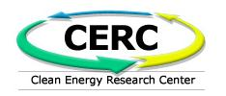
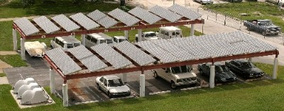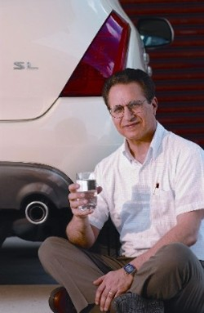
University of South Florida
Clean Energy Research Center
4202 E. Fowler Avenue, ENB118
Tampa, FL 33620
Email: cerc@eng.usf.edu
Web: http://cerc.eng.usf.edu
Ph: (813)974-4787
Fax: (813)974-5250

Center Accomplishments
- Received over $8 million in contracts and grants in the past ten years.
- Developed the Nation’s first 20,000 watt solar/electric charging station for electric vehicles.
- Achieved a world record efficiency (15.8%) thin film cadmium telluride solar cells for low cost applications.
- Developed the Rivolta Isigo neighborhood electric vehicle.
- Created a mobile data acquisition system for the US Department of Energy EV Site Operator program.
- Microturbine power plant fueled by landfill gas has been constructed at the Hillsborough Heights Landfill in Tampa.

The Center will achieve its mission and future accomplishments through scientific research, technical development, infrastructure development and information transfer. Collaboration with energy producers and the transportation sector will support economic development of manufacturing and high technology businesses as well as the nations goals of global competitiveness and technology leadership.

CERC R&D Areas

Clean Energy and Systems
- Solar energy
- Thin film solar cell R&D
- Photovoltaic and hybrid systems
- Hydrogen fuelled systems
- Biomass derived fuel and systems
Distributed Energy production
- Fuel Cells
- Microturbines
- Landfill gas utilization
- Energy management systems
- Solar “roof-top” systems
- Cost analysis
Energy Storage
- Hydrogen production and storage
- Battery Technology
- Hydrogen Liquefaction
- Underground storage of natural gas and landfill gas
Transportation Technology
- Electric/hybrid vehicles
- Fuel cells
- Vehicle operational testing
- Infrastructure development
- Energy management

CERC Key Projects
- By-Product Hydrogen Production with an Electrochemical Cell (reverse Fuel Cell)
- Electrochemical Catalytic Cell for the Production of Hydrogen from Various Fuel Stocks
- Prototype and Simulation Model for a MEMS Magneto-caloric Refrigerator
- Hydrogen Cryogenic Storage Systems
- Hydrogen Sensors for Fuel Cell Applications
- Rectenna Development
- Solid-State Fuel Cell for High Power Applications
- Photovoltaic Thin Film Technology
Production of Energy from Biomass
- Photocatalytic Bacteria Destruction in Air Handling Applications

CERC Mission

To develop, evaluate and promote commercialization of new environmentally clean energy sources and systems such as hydrogen, fuel cells, solar energy conversion, biomass utilization, etc., that meet the needs of the electric power and the transportation sector through multi-disciplinary research, technical and infrastructure development and information transfer. The Center supports regional economic development of manufacturing and high technology business, in conjunction with the National goals of improving our global competitiveness and technology leadership. Florida has no substantial indigenous supply of fossil fuels. It must import virtually all the energy it uses. However, Florida, the Sunshine State, has good solar and biomass resources. Solar and hydrogen resources and technologies, applied both electrically and thermally, can mitigate the State’s fossil fuel dependency, improve the environment and provide substantial economic growth opportunities.

