Climate Change Summit

Florida Governor Charlie Crist opened the green technology expo “Climate Change Summit: Serve to Preserve,” in Miami during Summer 2008. Crist discussed Florida’s energy and economic future. CERC’s display of a photocatalytic detoxification system drew interested observers.

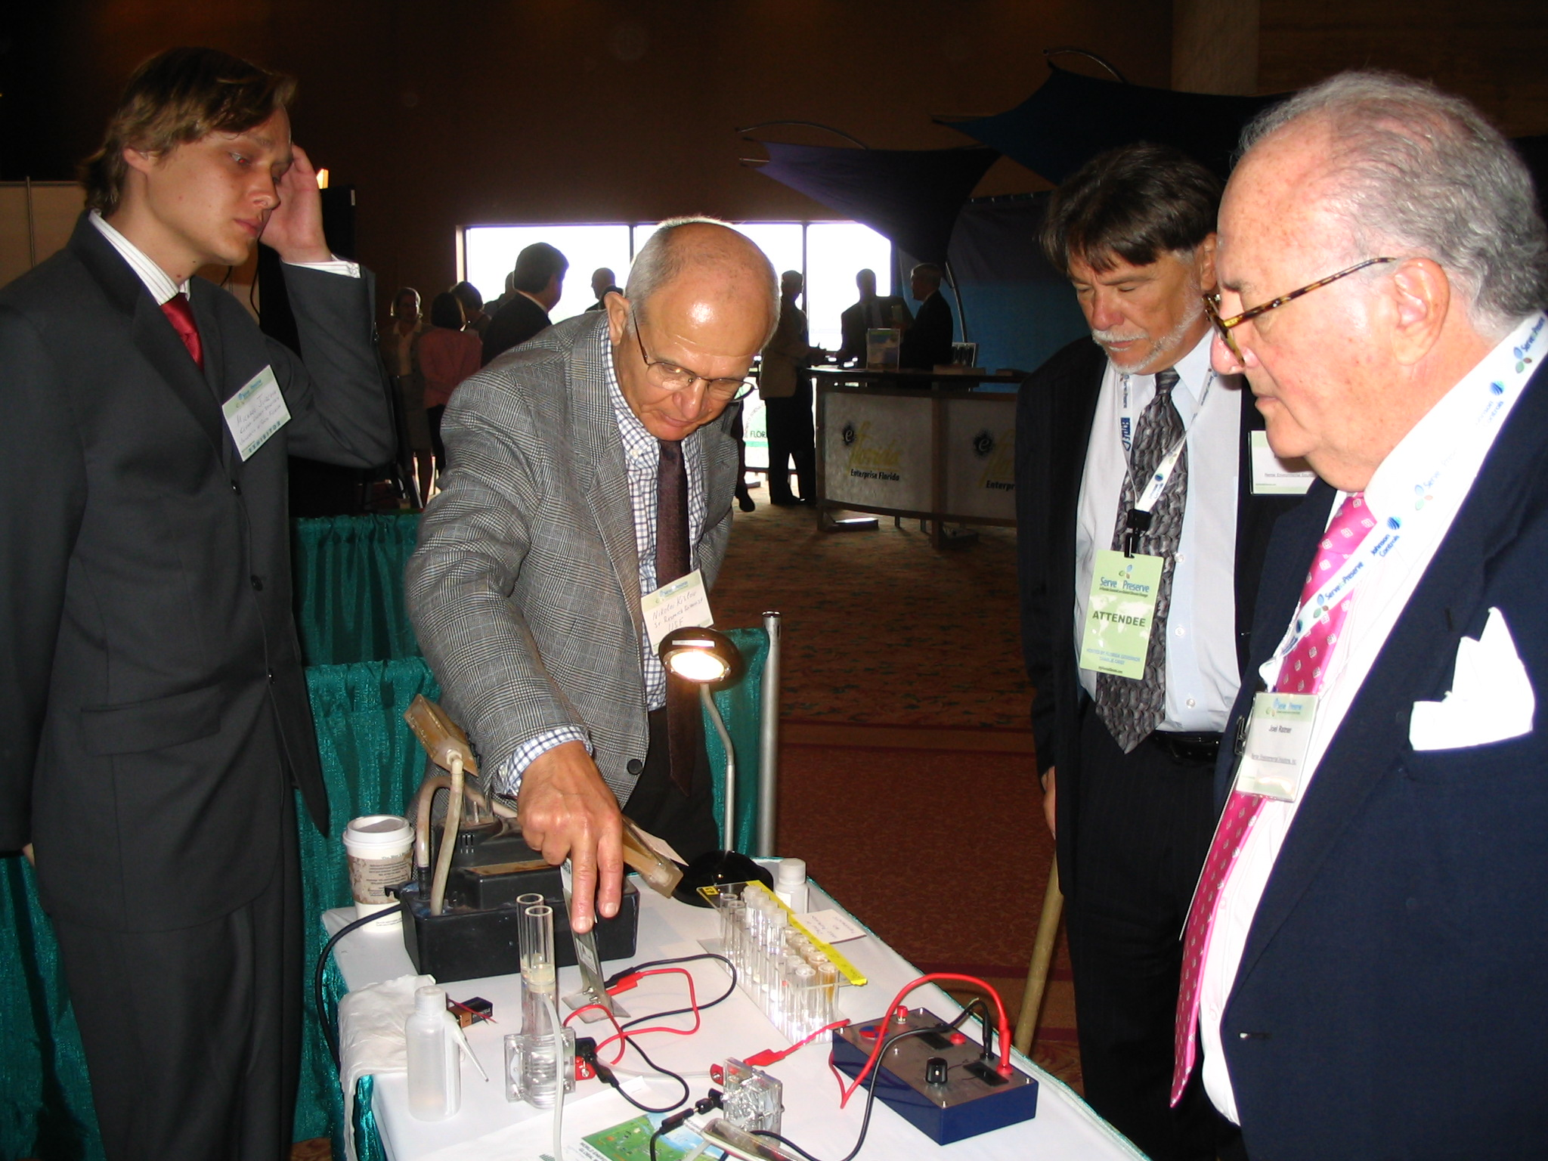

Pictured are (L-R): CERC researchers Michael Niemann and Nikolai Kislov with summit attendees.

