Honors and Awards

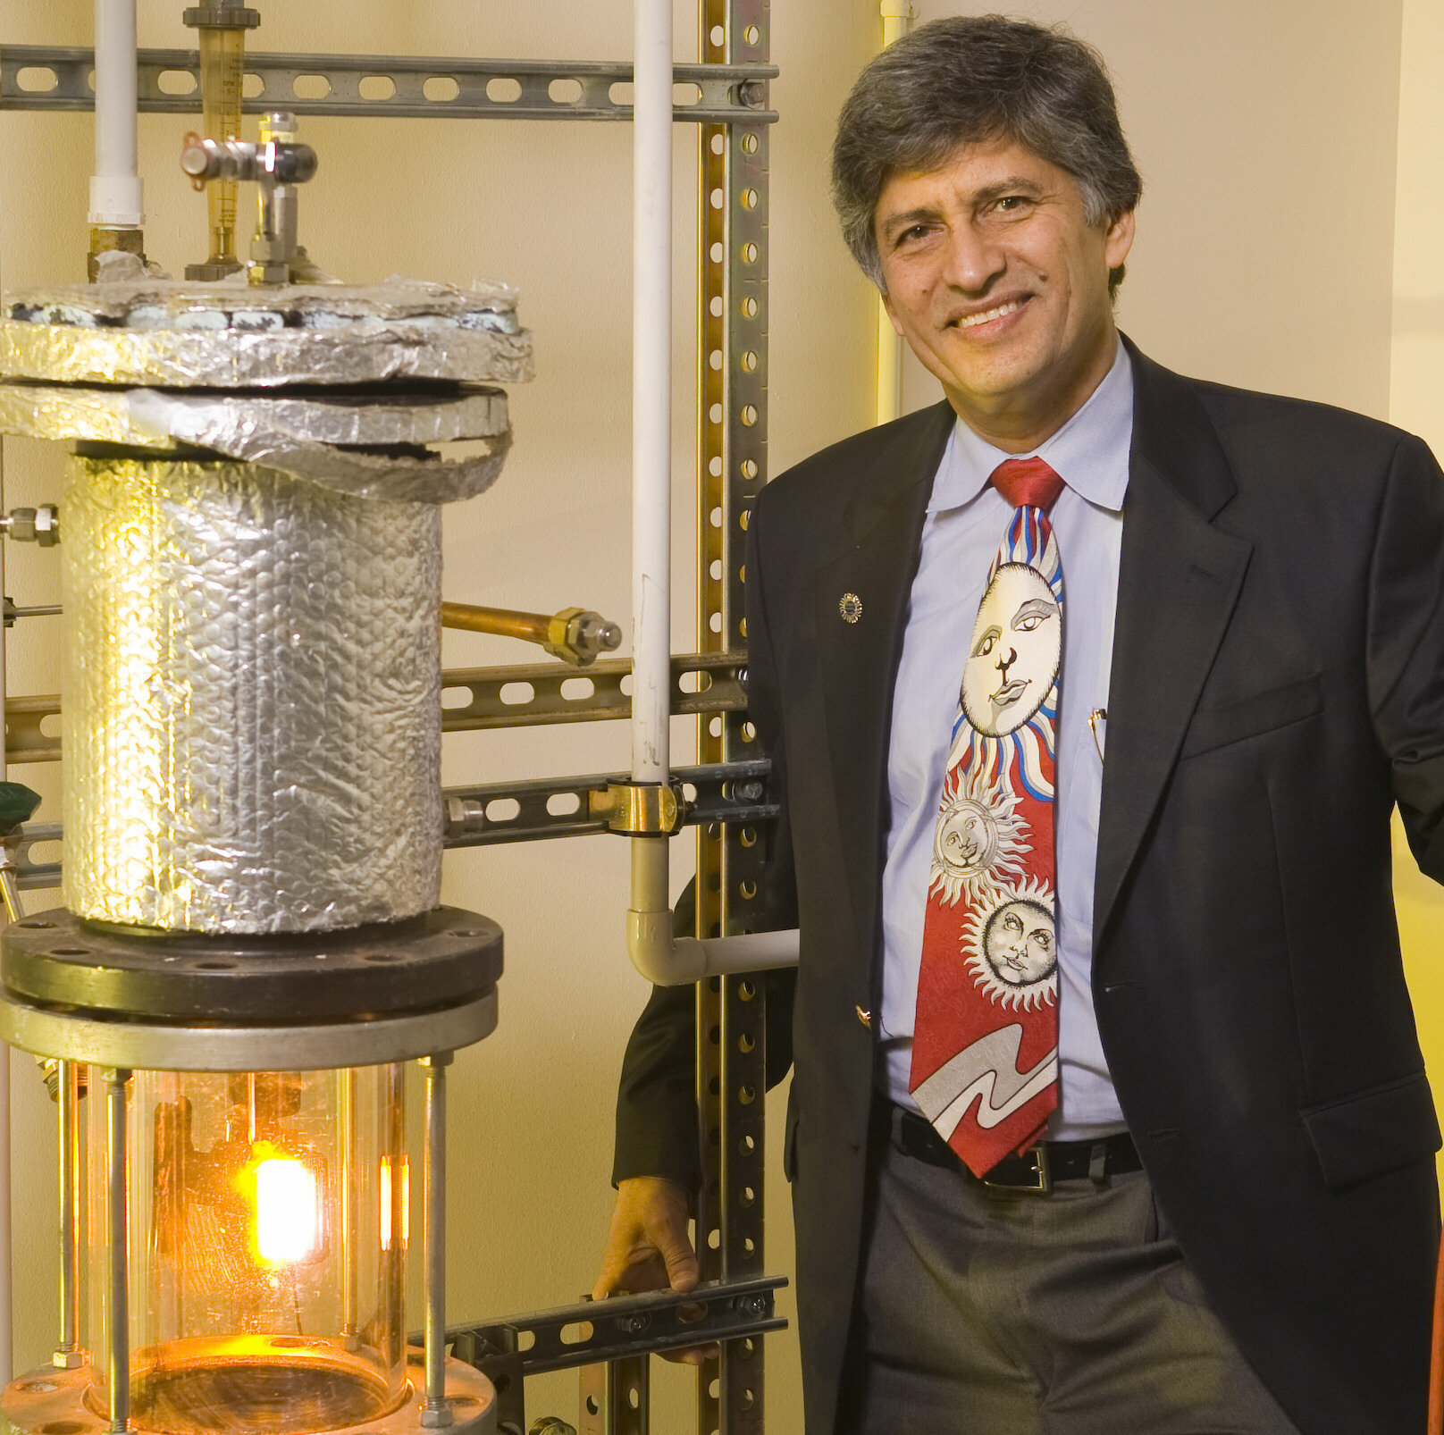
- USF awarded the Outstanding Faculty Research Achievement Award for 2008 to Yogi Goswami, CERC Co-Director. The USF award recognizes faculty for who have earned national and international recognition in their fields. Goswami was recognized for receiving the Frank Kreith Energy Award from the American Society of Mechanical Engineers; the Farrington Daniels Award from the International Solar Energy Society; and the Hoyt Clark Hottel Award from the American Solar Energy Society, for his continuing contributions to the fields of renewable energy, solar energy and energy conversion. Dr. Goswami appeared on the Faculty Spotlight website page for the USF Office of the Provost and Senior Vice President in September.

- Dr. Goswami was also awarded the “Outstanding Indian Citizen of the Year” from the Federal Indian Association/Tampa Bay in August 2008. The award honors Americans of Indian origin who excel in their professional and community activities. A previous winner was Dr. Renu Khator, then USF Provost, now Vice Chancellor of the University of Houston.

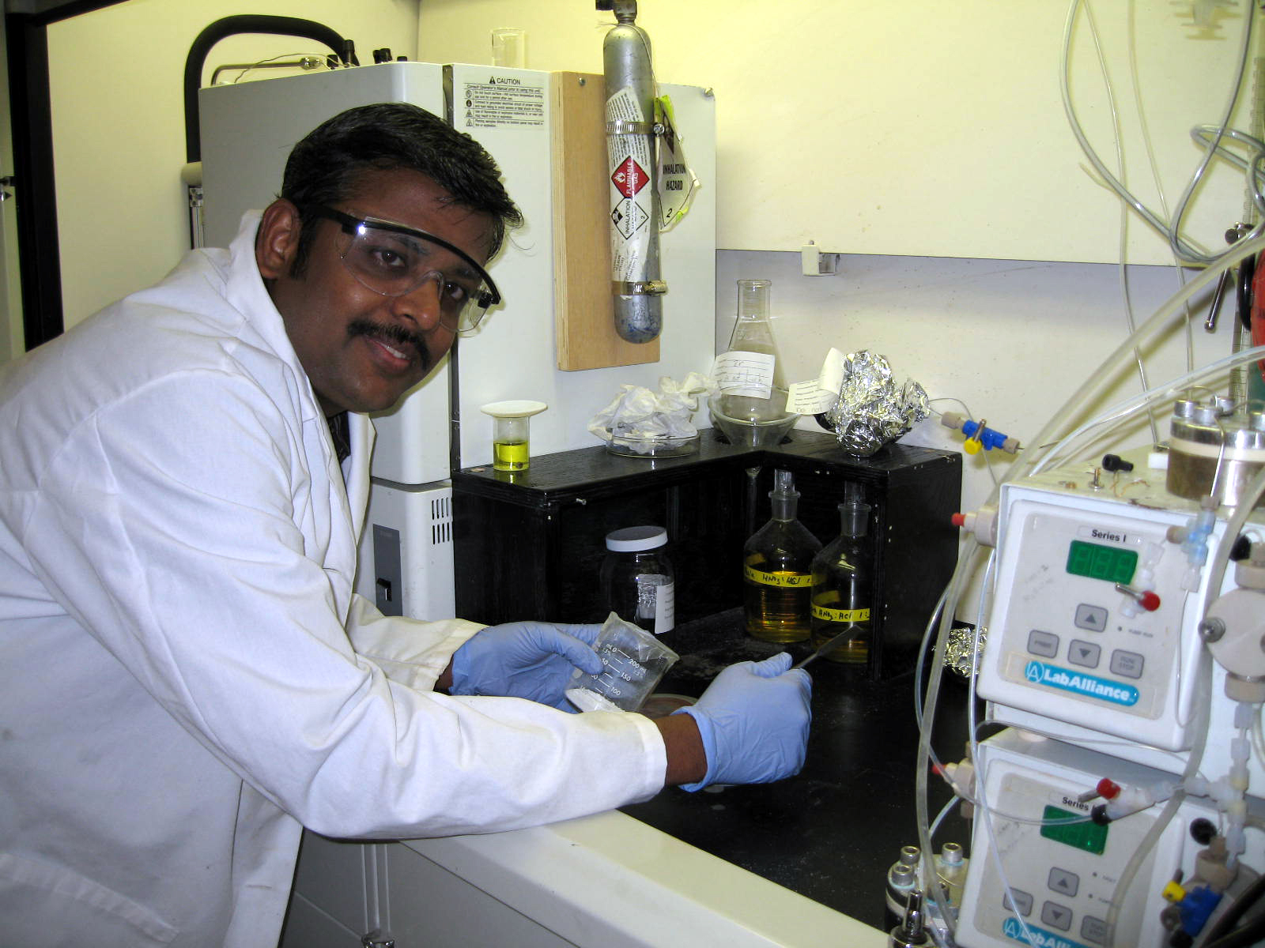
- CERC researcher Dr. Sesha Srinivasan received a Certificate of Excellence for his presentation “Nanomaterials for Energy and Environmental Applications” at the NanoFlorida 2008 during September. NanoFlorida 2008 is the first annual NanoScience Technology Symposium held at the University of Central Florida in Orlando.

- Dr. Srinivasan also gave a presentation at the Rotary Club Int’l. of Zephyrhills in September. His presentation highlighted practical solutions everyone can use to decrease our energy consumption. This is the second time the Zephyrhills Rotary Club has requested speakers from the CERC; previously Dr. Yogi Goswami presented a talk on peak fossil fuel.

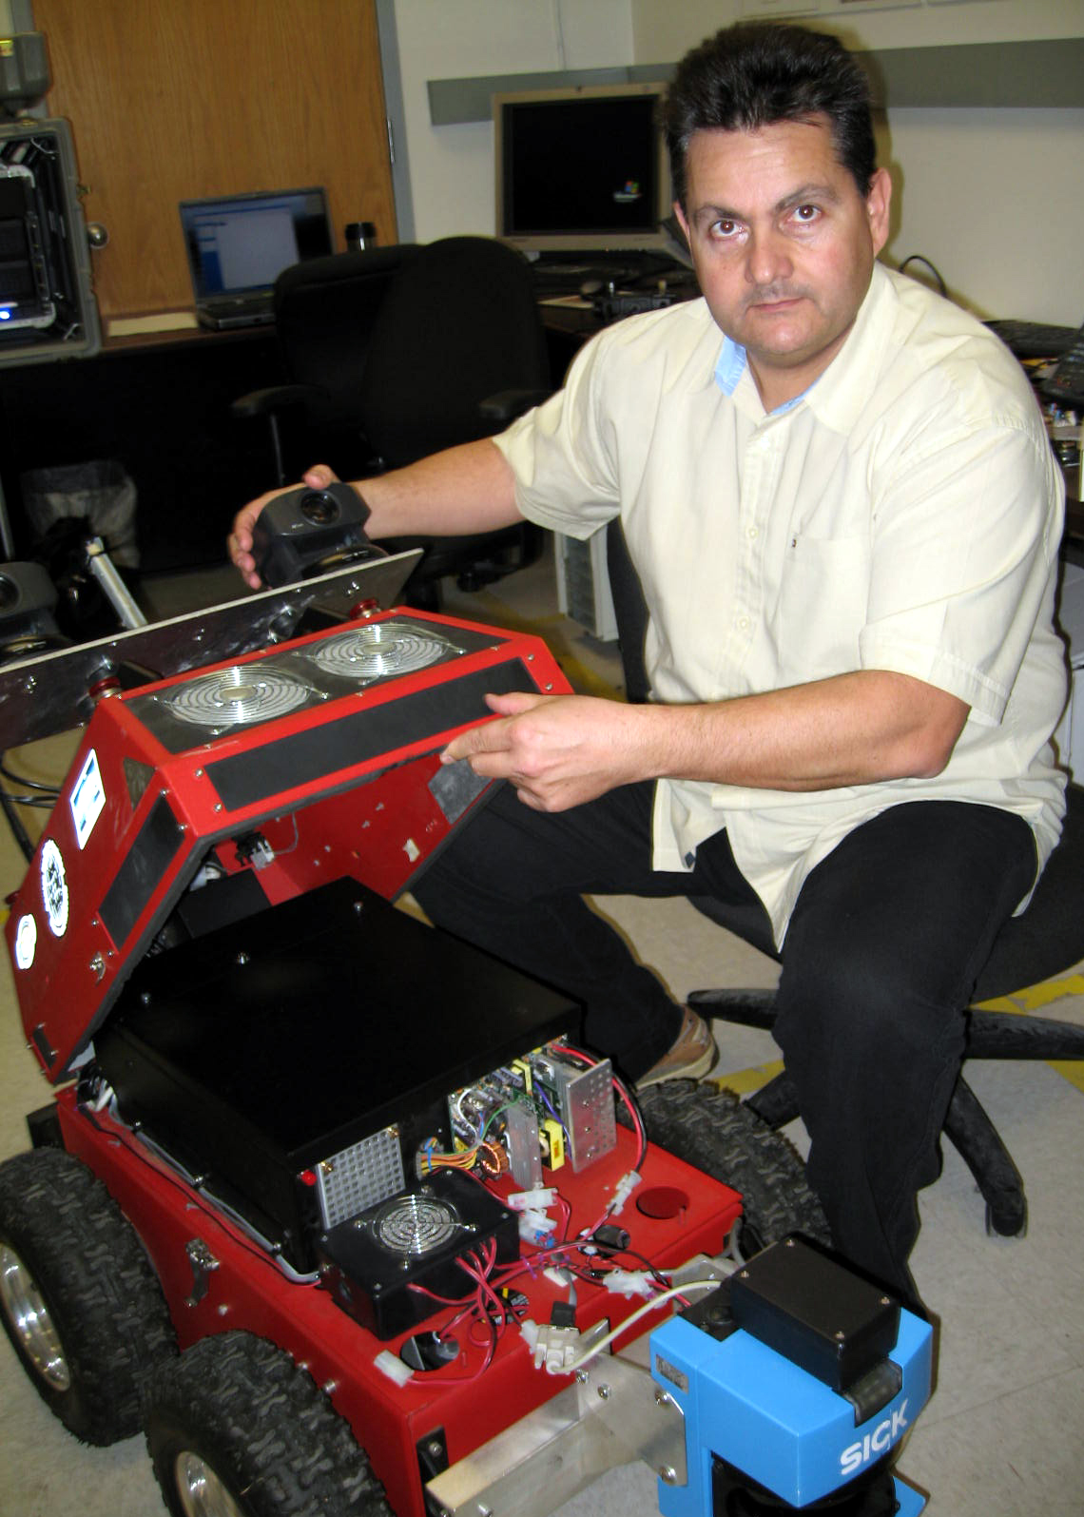
- CERC affiliate Faculty, Prof. Kimon Valavanis, has become the Chairman of the Electrical and Computer Engineering at the University of Denver in Colorado. Valavanis was previously a professor in the USF Department of Computer Science and Engineering, where he also served as Deputy Director at the Center for Robot-Assisted Search and Rescue (CRASAR) until the summer of 2005. In 2006 he created the Unmanned Systems Laboratory, where he served as its Director. Valavanis is also the chief editor of the Journal of Intelligent and Robotic Systems, and the IEEE SMC e-Newsletter.

