One University: One Community: One Vision
USF “Research One” … Innovation and Achievement

Celebrating research through a week-long showcase from all areas throughout the University, USF’s “ResearchOne” was held Nov. 3-7, 2008. Awards were presented Nov. 7 to category winners for outstanding research achievement, excellence in innovation, and graduate student research. CERC co-director Yogi Goswami received one of the USF Outstanding Research Achievement Awards.

In support of USF’s Research Week, the College of Engineering (CofE) hosted events aiming at strengthening CofE’s research community by providing an informal setting for information exchange and bridge building. Geared to attract undergraduate students, these events provide valuable exposure to CofE’s exciting research opportunities. The events celebrated the broad range of inter- and multi-disciplinary research pursued by the engineering college.

During the Nov. 4 leg, “Energy, Sustainability and Infrastructures/Transportation Power Presentations” held at the Engineering “Fish Bowl,” CERC researchers presented two posters, one highlighting the work at the Clean Energy Research Center, and a second for CERC as a part of the Florida Energy Systems Consortium. Sesha Srinivasan and Michael Niemann discussed CERC’s diverse project areas to interested attendees, one of whom was Dr. Karen Holbrook USF Vice President of the Office of Research and Innovation.
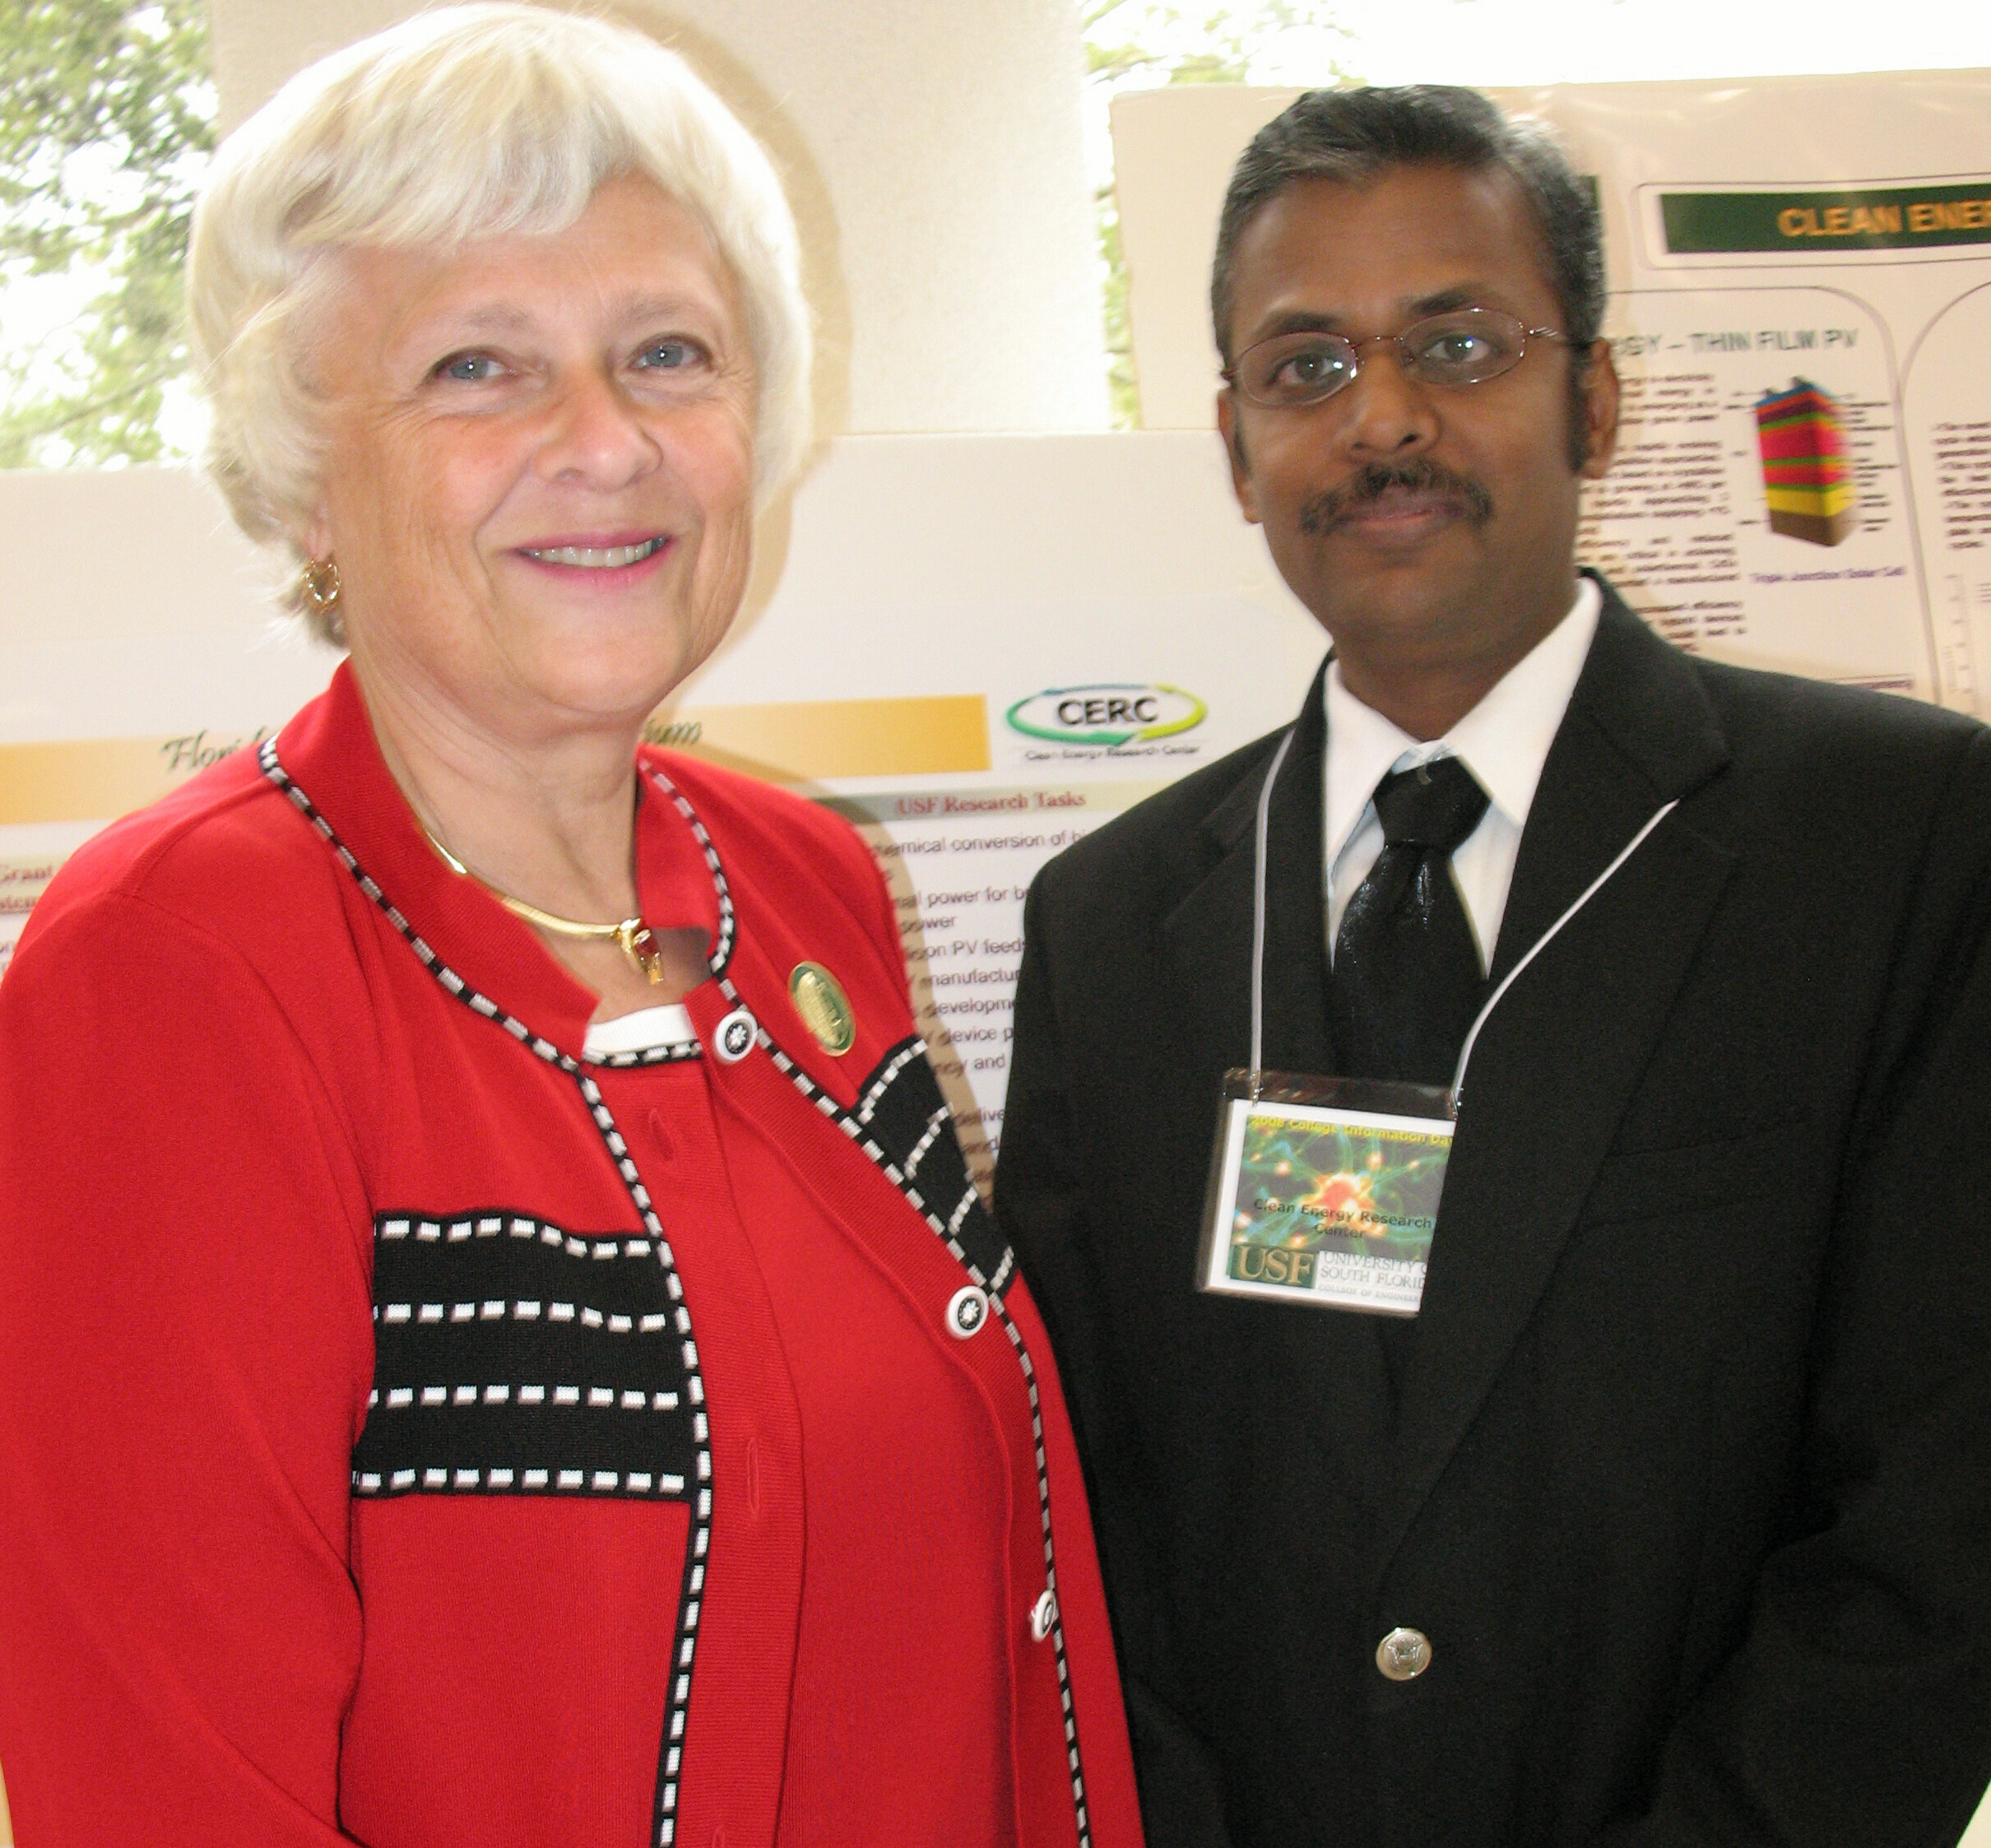

Pictured (L-R): Karen Holbrook, USF Vice President of the Office of Research and Innovation, and CERC researcher Sesha Srinivasan.

Graduate student research was emphasized during “College of Engineering Research Day” on Nov. 5 held at the Interdisciplinary Research Building Galleria. CERC graduate students Mohammed Abutayeh, Drupati Latchman, Huijuin Chen, Pabitra Choudhury, Subramanian Krishnan and Michael Niemann each displayed posters focusing on their research.

- Environmentally Sustainable Flash Desalination (Mohammed Abutayeh)
- Thermodynamic Cycle (Huijuin Chen)
- Thermochemical Hydrogen Production and Carbon Capture (Drupati Latchmen)
- Hydrogen Storage Materials (Pabitra Choudhury)
- Exotic Polyaniline Nanostructures for Hydrogen Storage (Michael Niemann)

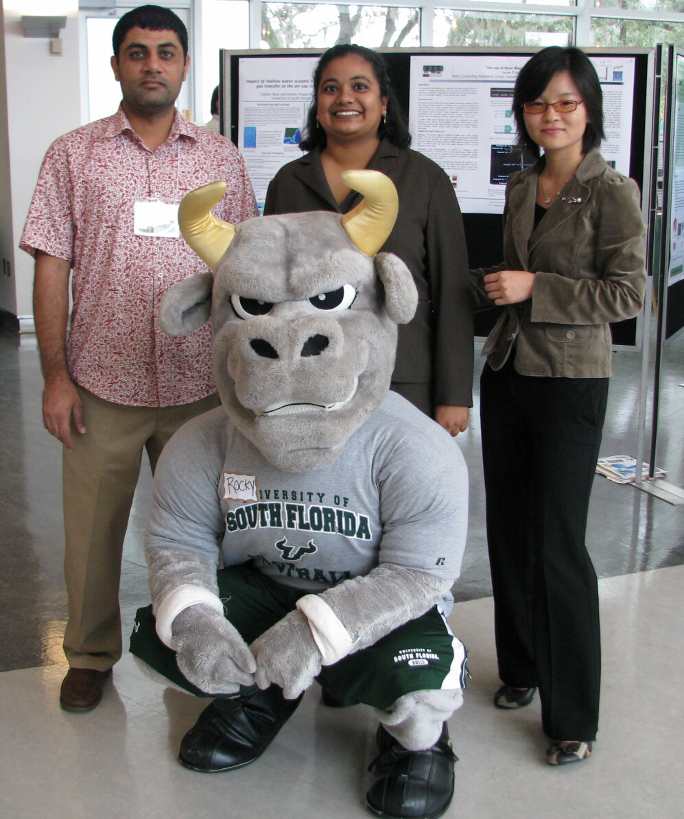
USF’s mascot, Rocky, with CERC graduate students (L-R): Mohammed Abutayeh, Drupati Latchman and Huijuin Chen.

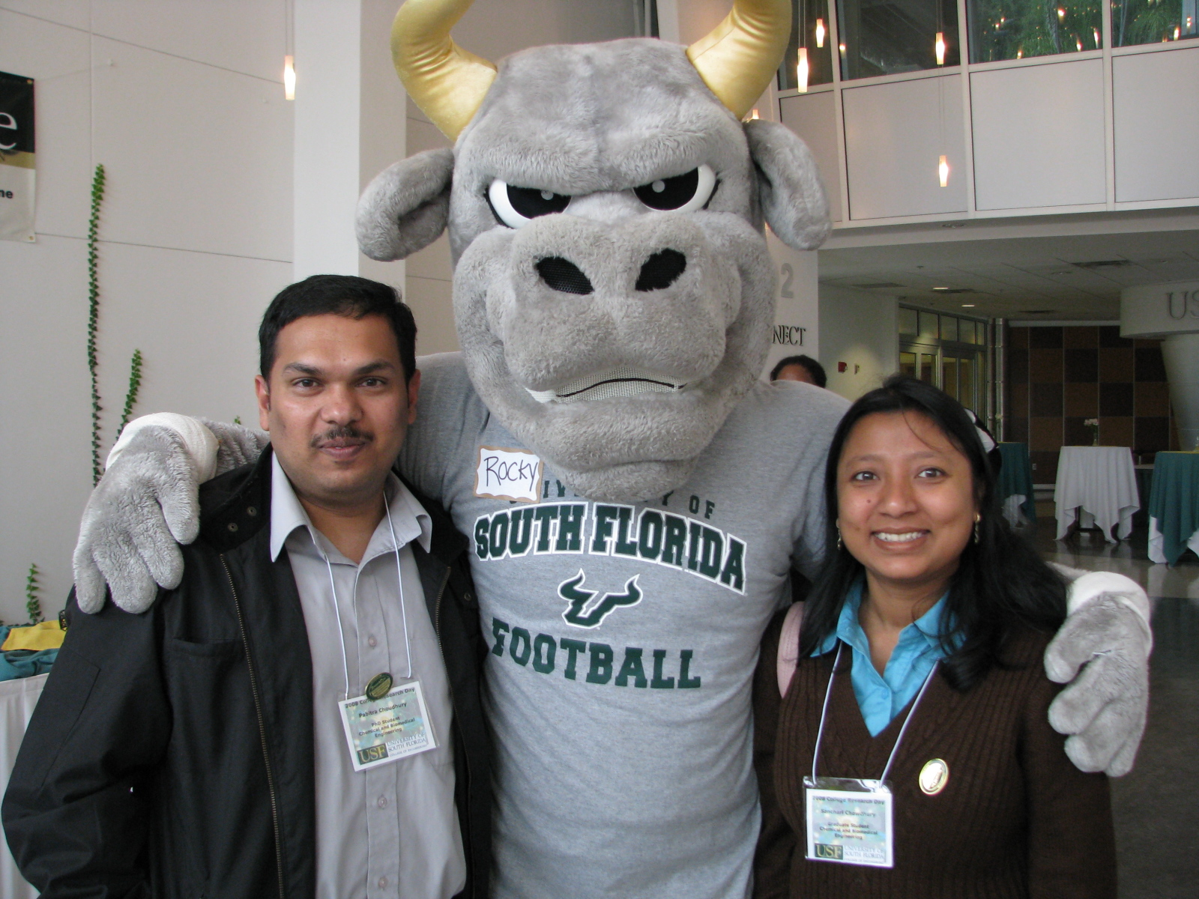

Pictured (L-R): CERC grad student Pabitra and Sanchari Choudhury flank USF’s Rocky.

