USF TECO Energy Forum

Showcasing energy research to highlight solutions for the State of Florida was the foundation for “An Energy Forum to Discuss Energy Solutions” in October 2008. The University of South Florida (USF), Greater Tampa Chamber of Commerce and Tampa Electric Company (TECO) collaborated in demonstrating how scientists in the Tampa Bay are major contributors to energy research in the State and the nation.

Florida’s U.S. Senator Mel Martinez spoke at the Forum which showcased energy research from throughout the USF and Tampa Bay research sectors. Joining Martinez were, among others, St. Petersburg Mayor Rick Baker, Tampa Port Authority Director Joe Wainio, Chuck Black of TECO, USF Provost Ralph Wilcox, College of Engineering Dean John Wiencek, and CERC Directors Lee Stefanakos and Yogi Goswami.

CERC researchers fielded five technical poster presentations demonstrating the breadth and range of our ongoing energy investigations. These included:

- Clean Energy Research Center – overview of research activities of the CERC
- Florida Energy Systems Consortium
- Solar Desalination for Potable Water
- Thermodynamic Cycle Simulation
- Hydrogen Production from Solar Photovoltaics

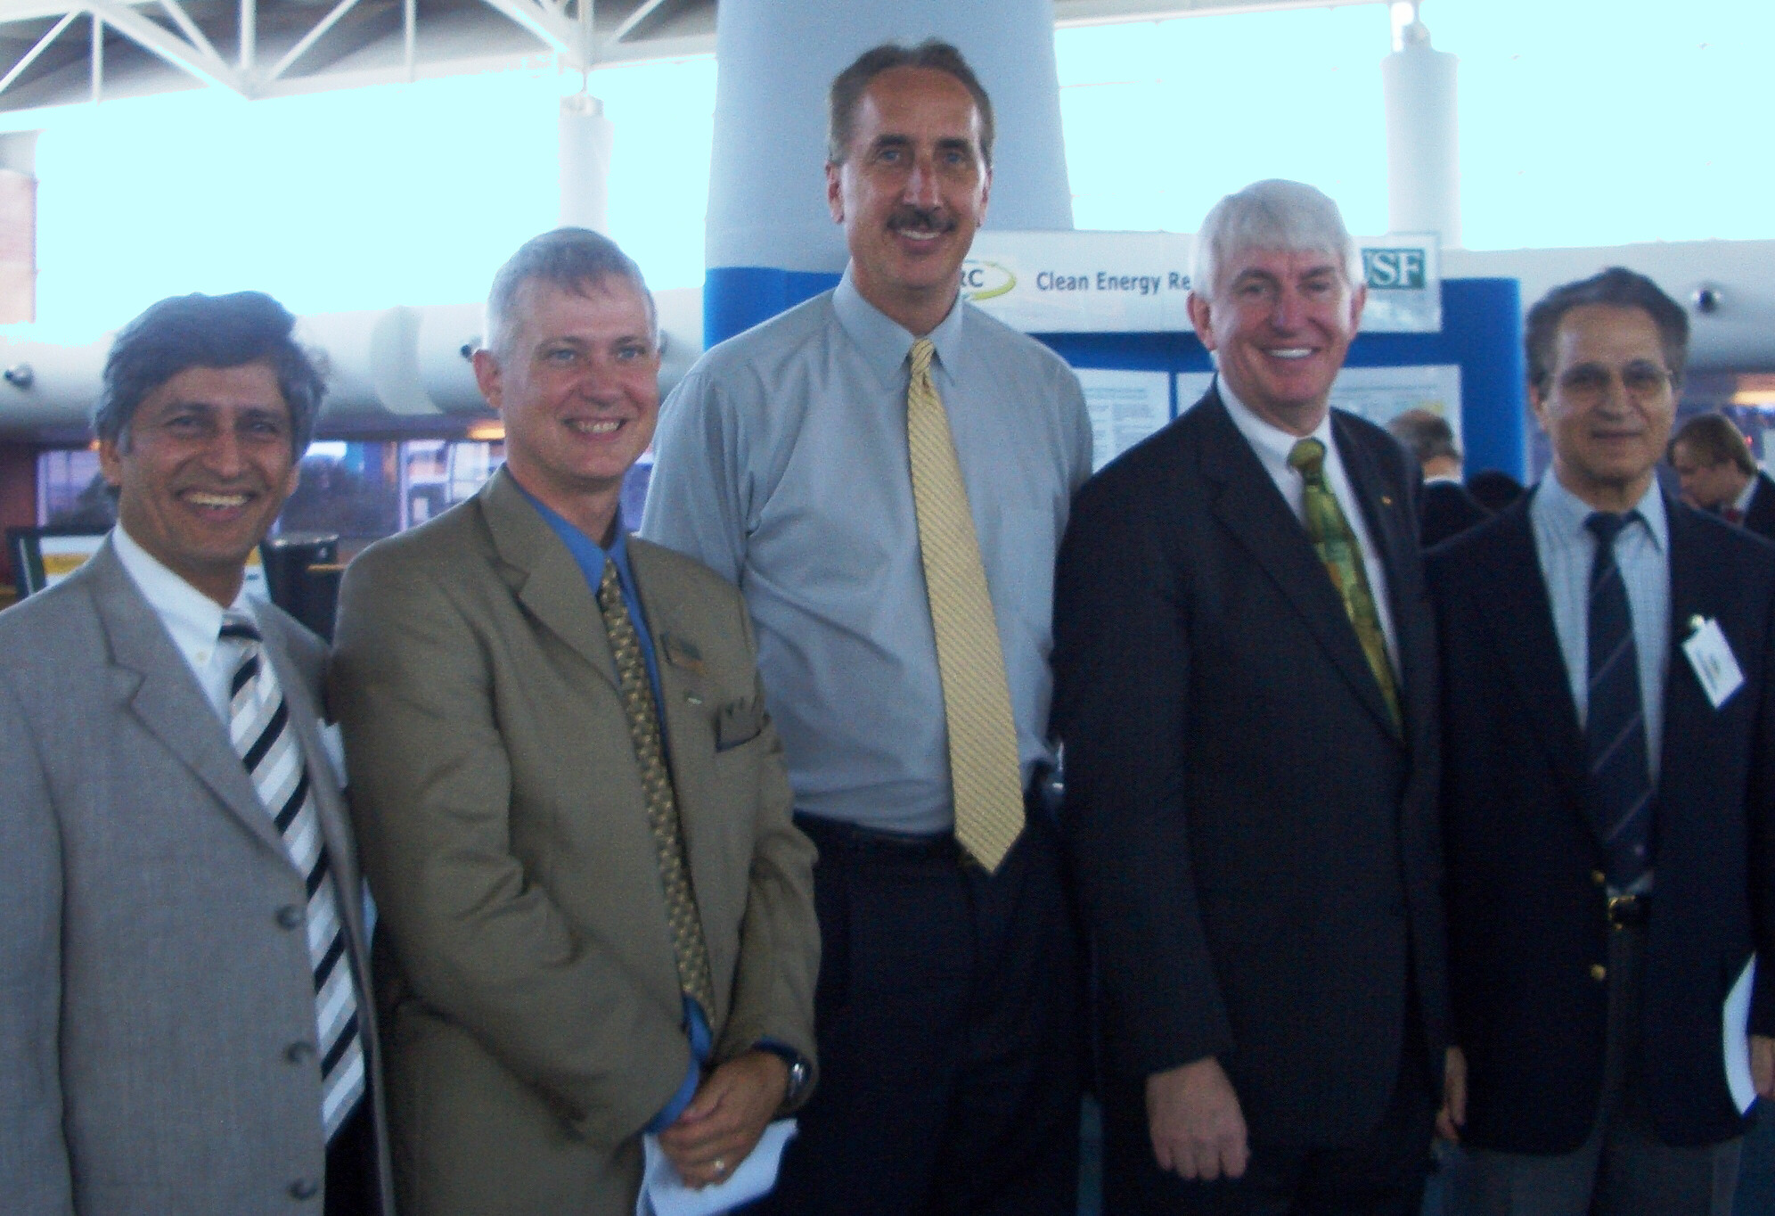

Pictured are (L-R): CERC Co-director Yogi Goswami, College of Engineering Dean John Wiencek, St. Petersburg Mayor Rick Baker, USF Provost Ralph Wilcox, and CERC Director Lee Stefanakos.

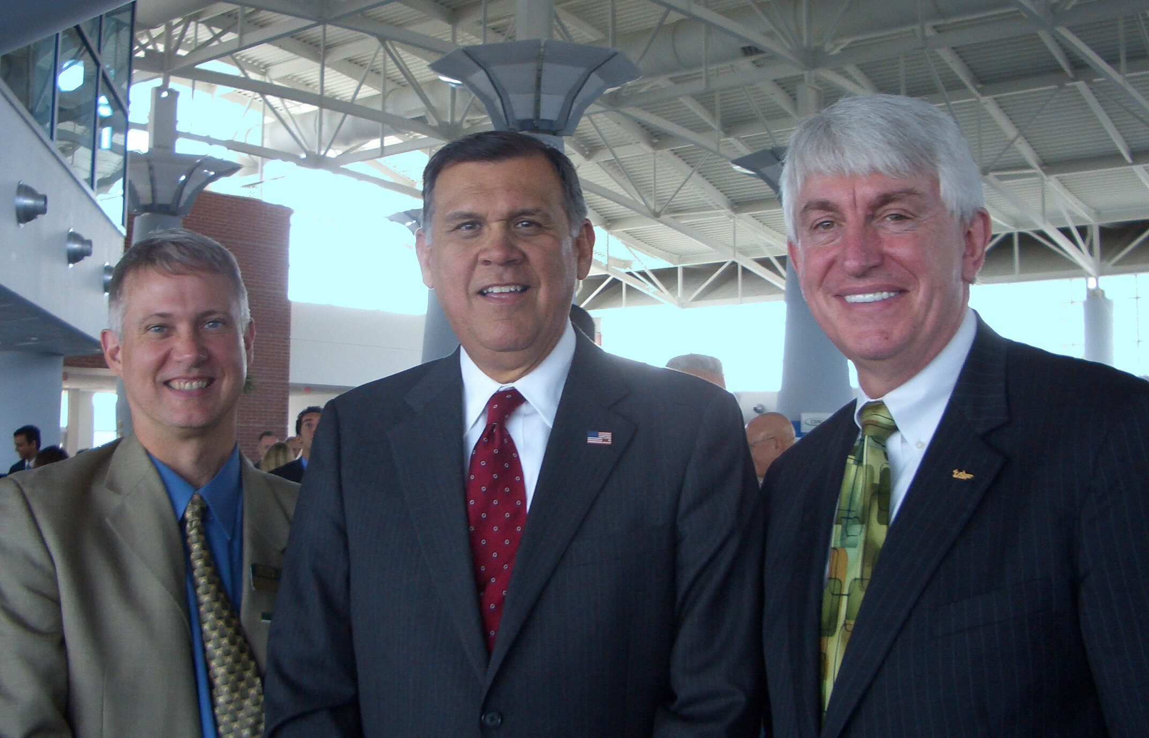

Pictured are (L-R): College of Engineering Dean John Wiencek, U.S. Senator Mel Martinez, and USF Provost Ralph Wilcox.

