Kids Are STARS

Summer camps are not what they used to be for kids. Now there are specialized camps for all careers, sports, arts, and other unique subjects. STARS is ideal setting for the child who is enthralled with chemistry, engineers, scientists, and inventors.

The Students, Teachers and Resources in the Sciences (STARS) Summer Camp 2008 drew quite a number of middle schoolers to the USF to participate in meaningful science activities with hands-on demonstrations of various engineering areas. STARS camps provide a kaleidoscope of activity and training opportunities for young people.

CERC graduate students Ricardo Vasquez, Gokmen Demirkaya, Huijuin Chen, Drupati Latchman, Michael Niemann, Sam Wijewardane, Pabitra Choudhury, gave deomonstrations of current research at the Solar Charging Station adjacent to the ENB/Glenn Burdick Hall. Demonstrations included:

- Solar charging (PV panels)
- Hydrogen production (electrolysis process) and conversion through fuel cells
- Hydrogen fuel cell and solar driven vehicle
- Solar oven
- Photocatalytic water disinfection

CERC’s solar oven and hydrogen powered car were absorbing to the kids!

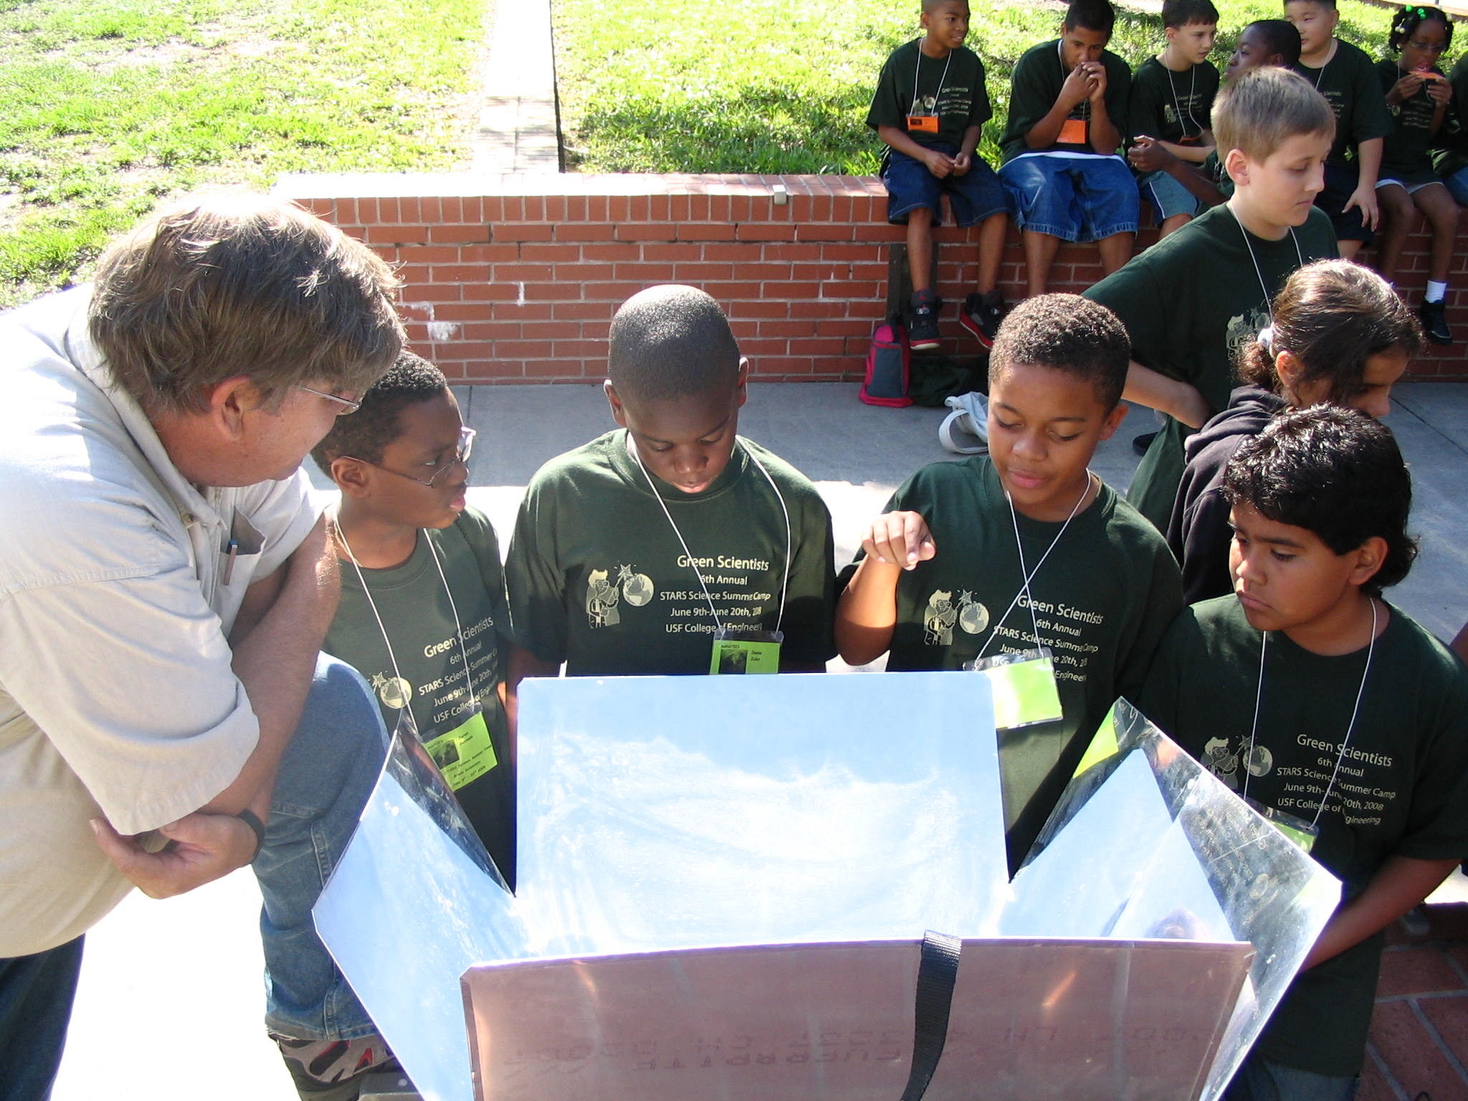

CERC Laboratory Coordinator Chuck Garretson discusses the science behind a solar oven.

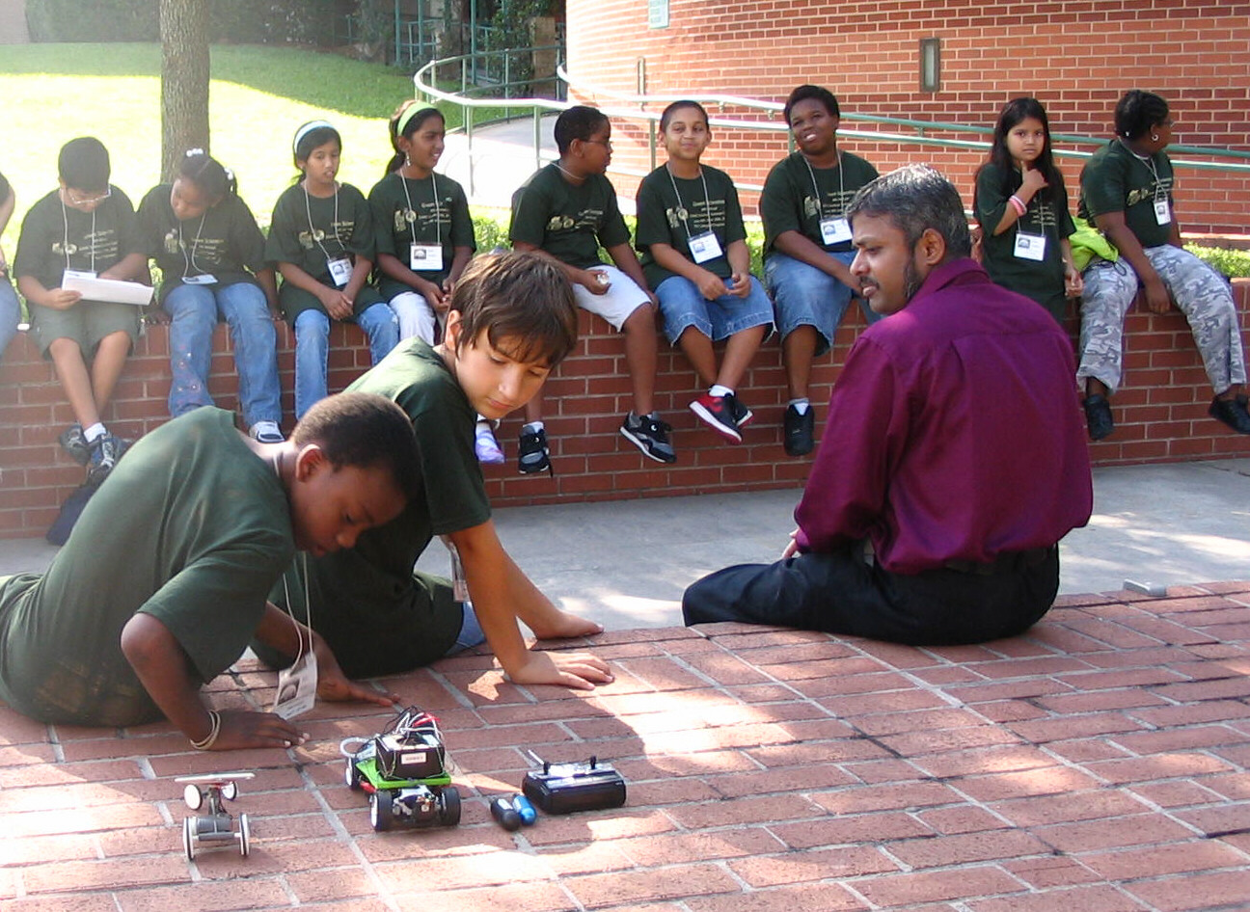

CERC faculty Sesha Srinivasan demonstrates a hydrogen powered car.

