Solar Detoxification

According to UNICEF, nearly 6,000 people die each day due to water-related illnesses ― but the indoor air environment is considered one of the most important health concerns for industrialized nations. Indoor air pollution can be 2-5 times higher than outdoor pollution due to poor air exchanges and accumulation. Now with concern over bioterrorism, the biggest danger from biohazards, such as anthrax, arises when they become airborne and spread through building ventilation systems. Conventional air filtration systems are inadequate to provide a satisfactory solution. Drastic measures, such as fumigation with Chlorine Dioxide have serious consequences. Dr. Yogi Goswami pioneered the development of the photocatalytic detoxification technology for air clean-up that overcomes these problems better than any other existing technology such as the Electrostatic or HEPA air filtration systems. Photocatalytic detoxification’s ability to zap mites, molds, spores and many other pollutants has lead to its commercialization. A 2nd generation of the technology developed by Dr. Goswami has also been commercialized. The USF’s Clean Energy Research Center, led by Drs. Elias Stefanakos and Yogi Goswami, is conducting research to develop the 3rd generation technology. The thrust of USF’s research in improving the photocatalytic disinfection technology is to enable its use against bioterrorism by reducing the time needed for complete oxidation to a fraction of a second. Another research objective is to develop new semiconductor photocatalysts that use visible light to increase the efficiency and decrease the system cost of an advanced photocatalytic air disinfection system.

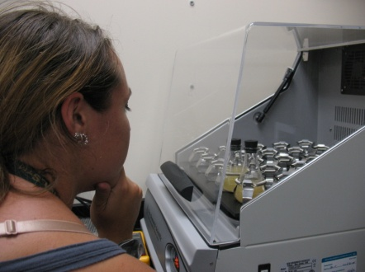 | 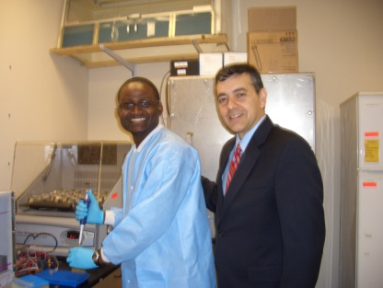
Bacteria are grown to test photocatalytic disinfection. | FL Rep. Rivera (R) visited CERC labs and viewed photocatalytic wet bench experiments.

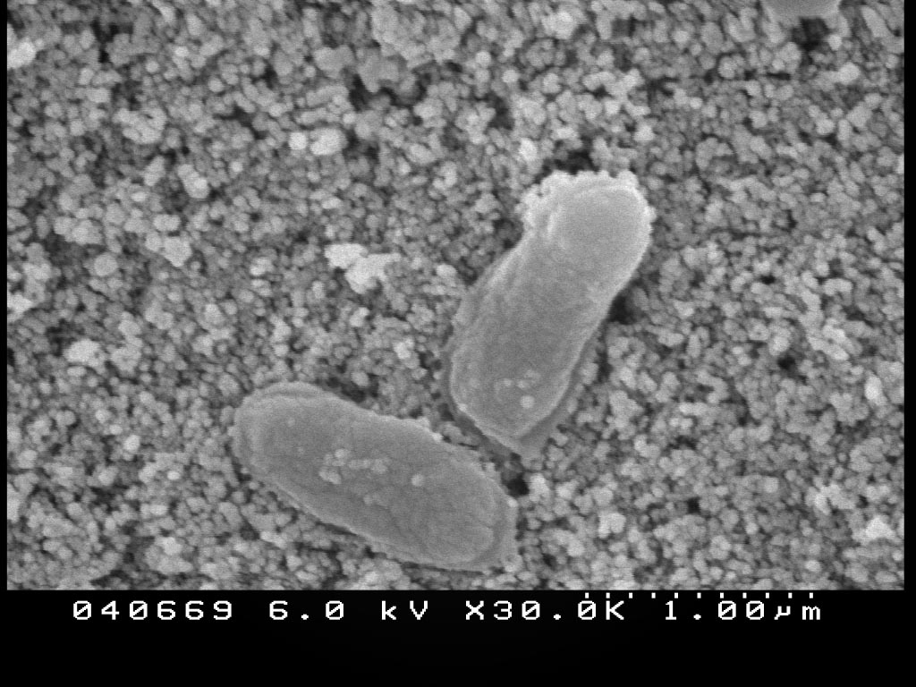 | 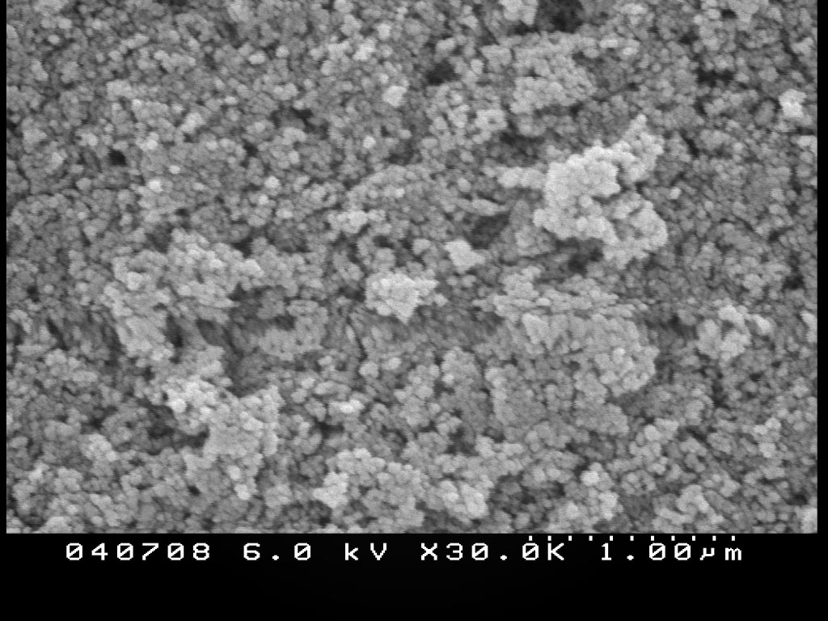
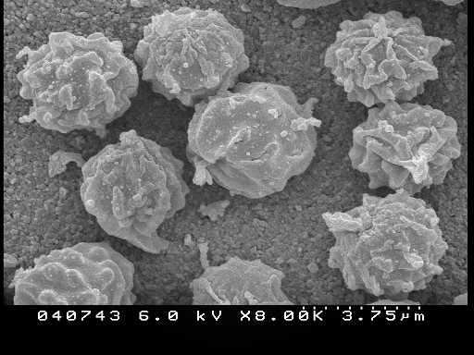 | 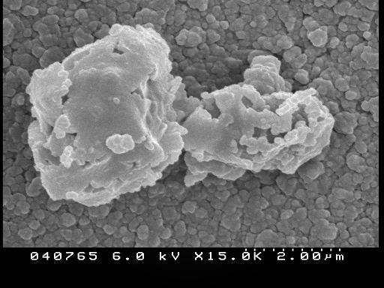
Before | After
Destruction of mold spore, aspergillus niger, and bacillus subtilis, a spore that causes food spoilage (and is a cousin of the anthrax spore, bacillus anthracis) through photocatalytic disinfection.

