**CERC IN THE COMMUNITY**

* Energy, environment and economics … that’s what the “E3 Fall Forum: The Art of Sustainability” was about, held in September at the Stratz Center for Performing Arts in Tampa. For the second consecutive year, CERC displayed at the E3. This regional forum on local initiatives looks at sustainability, building, alternative fuels and energy management. Steve Thomas, television host of “Renovation Nation,” was a featured speaker at the Forum.

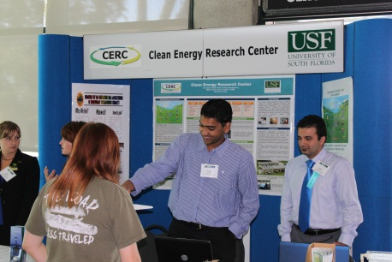

CERC graduate students Rudy Ratnadurai and Saeb Besarati (C-R) explain some of the Center’s research.

* Raising on-campus awareness about sustainability, 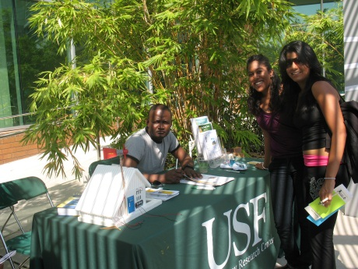the USF Office of Sustainability and the Student Environmental Association (SEA) co-hosted a public awareness day with the major theme of energy and oil independence in October. Held at the Marshall Center Amphitheater, the CERC displayed a variety of solar powered toys and information flyers. The SEA educates the community about the environment and works towards making USF more environmentally-friendly.

Graduate Student Kofi Dalrymple explains solar energy to interested students.