**CONCENTRATED SOLAR POWER SHINES ON USF**

A green light is shining on CERC’s mission to build a concentrating solar power (CSP) plant on the USF Tampa campus adjacent to the Research Park. FESC PI Yogi Goswami’s aim is making solar energy available 24 hours a day at affordable prices. CSP is used to focus the sun’s rays generating heat and electricity. When combined with heat storage CSP plants can then produce climate-friendly electricity around the clock, even when the sun is not shining.

With multiple funding sources, the stage is now set for Goswami’s CSP research to blossom. The US DOE awarded a multiyear initiative to Goswami and his team for “Base-load Concentrating Solar Power Generation.” Combined with the DOE award, the State of Florida through the Florida Energy Systems Consortium, and SunBorne Energy Technologies, India, awards for “Development of a Modular Central Receiver Concentrated Solar Power Plant for Decentralized Power Generation” now provide a solid platform for continued ground-breaking research.

A vital area of the CSP research is developing and demonstrating a thermal energy storage (TES) system based on materials that absorb heat when changing from a solid to a liquid and release heat when changing from a liquid to a solid. The objective is to create a TES system based on encapsulated phase change materials to meet the utility-scale base-load CSP plant requirements at much lower system costs compared to existing TES concepts.

TES will be a game changer for the entire energy industry. Hoping to put together storage that will be up to 5 times cheaper than what is available right now, CERC’s research team will bring solar power to grid parity, which means it will cost the same as traditional fossil fuels such as coal, oil or even nuclear power -- when that happens solar power will be the preferred fuel as it does not cause any environmental problems.

This research will impact the future of solar energy in the world, being at the forefront of the field. Such a power plant has sparked a great deal of interest by industry as well as academia. John Ramil, President and CEO of TECO energy, feels the facility will provide wonderful teaching and research benefits.

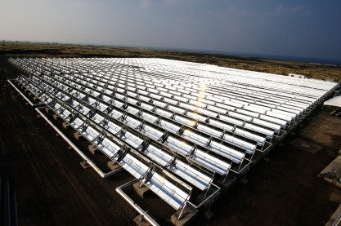

Example of a solar trough array.

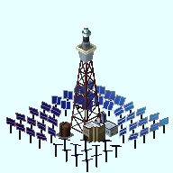

Example of heliostats arrayed around a concentrating tower.