**THERMAL ENERGY HEATS UP DYNAMIC RESEARCH**

Enhanced phase change material (PCM) capsules will be key to cost efficient thermal energy storage (TES). CERC will produce encapsulated PCM capsules of different sizes and melting ranges for use in several energy storage applications, such as space heating and cooling, solar cooking, solar water heating, industrial process heat, greenhouse and waste heat recovery systems.

CERC’s research, “Innovative Latent Thermal Energy Storage System for Concentrating Solar Power Plants,” won the coveted European E.ON Award for 2010, during a ceremony held in Berlin, Germany in September. The E.ON Research Award supports outstanding projects worldwide which develop future technologies in the field of energy.

PI Yogi Goswami is partnering with researcher Manuel Romeo from Spain’s IMDEA Energia in Madrid. E.ON’s generous awards for international ground-breaking energy research included $800K to CERC, which furthers the science of capturing latent heat for use in generating power.

The winners of the E.ON Research Award are five research teams from Europe and the USA who submitted proposals on the topic of "Heat Storage for Concentrating Solar Power". Concentrating solar power (CSP) technology can be used to focus the sun’s rays to generate heat and electricity. CSP plants combined with heat storage can then produce climate-friendly electricity around the clock.

The award ceremony was held on "Energy Day", the climax of the 2010 Science Year, as part of a joint event organized by E.ON and the German Federal Ministry of Education and Research. Representatives from politics, science and industry took part in a panel discussion on the issue of solar power. Dr. Georg Schütte, State Secretary at the Federal Ministry of Education and Research, and Prof. Klaus-Dieter Maubach, member of the E.ON Board of Management, made the presentations. 2010 is the third year in which the award has been presented.

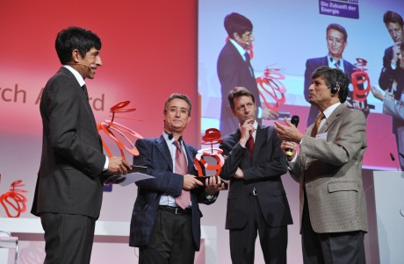

(L-R) Ranga Yogeshwar of E.ON presents the 2010 E.ON Research Award to co-PIs Dr. Manuel Romero (2nd from the left) and Dr. Yogi Goswami (far right).

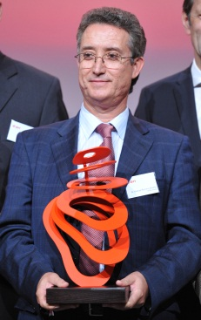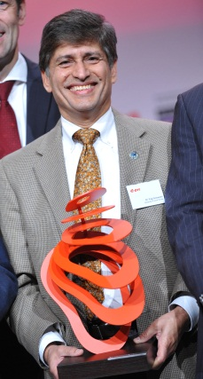

Yogi Goswami receiving E.ON Award.

Manuel Romero receiving E.ON Award.