**TAMPA BAY SOLAR TOUR**

Tampa Bay’s sunshine has a lot of uses … and making electricity out of sunbeams excited the public during the October “Tampa Bay Solar Tour” hosted by the CERC. This is the second year that CERC has hosted the Tampa Bay’s leg of the National Tour of Solar Homes of the American Solar Energy Society. The annual tour is held in conjunction with National Energy Awareness Month.

This year’s self-guided tour offered flexibility for the community to view the volunteer exhibitor’s solar energy systems. Home locations ranged from Tampa, to Plant City, to Land-o-Lakes, to St. Petersburg to Apollo Beach.

The solar tour offered an opportunity to tour innovative green homes and buildings to see how ordinary people can use solar energy, energy efficiency, and other sustainable technologies to reduce monthly utility bills and help tackle climate change. A focus of the tour is on energy-saving techniques and sustainability through building design, energy efficient appliances, and use of green materials during remodeling.

Now in its 15th year the ASES National Solar Tour is the world's largest grassroots solar event. More than 160,000 participants visited some 5,500 buildings in 3,200 communities across the U.S.

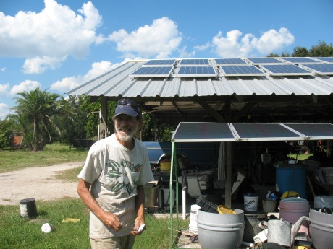

Jon Butts of “Eco-Farm” in Plant City embraces sustainable living. The organic garden generates its electricity and hot water from the sun. The sun powers the farm’s refrigerator, fertilizer injection pump, oven, dehydrator, golf carts, electric bikes, and a truck.

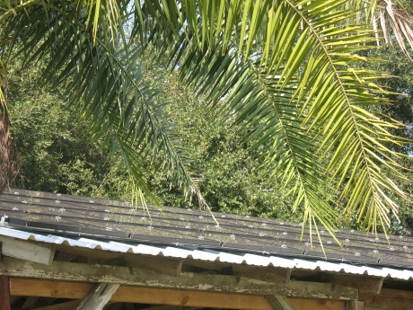

Eco-Farm’s thin film PV panels.

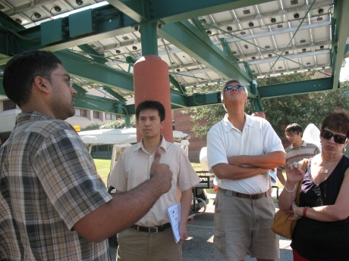

CERC graduate student Rudy Ratnadurai (L) explains the on-campus charging station which generates 20,000 watts of solar electricity from its PV array.



*if needed -- Boxed Sidebar:*

***PV SYSTEM SIZING BASICS***

*Utility companies measure electricity in terms of Kilowatt hours (kWh). If you look at your electricity bill, you’ll see a value for average daily energy use in kWh as well as the energy consumed for that month in kWh. The monthly value is the number that they use to calculate your bill. So you may wonder where this number comes from. A simple calculation may help you understand this.*

*We will use a light bulb’s energy consumption as an example. First you must know how much power a bulb requires. This power, whether AC or DC for any appliance or electronic device, is measured in Watts. Your energy use in kWh can be calculated by multiplying the power requirement times the number of hours that an electronic device is on for.*

*If for example, a light bulb requires 40 watts to run and you use the light 2 hours a day then your daily energy use for that light bulb is:*

*40 Watts x 2 hours = 80 watt hours per day*

*Day*

*If you use this light 7 days a week for every week of the month then your monthly energy use for that bulb is:*

*40 Watts x 2 hours x 7 days x 4 weeks x 1 kilowatt*

*day week month 1000 watt*

*= 2.24 Kilowatt hours(kWh) per month.*

*Therefore, this bulb will contribute 2.24 kWh to your monthly electric bill. If you use 10 bulbs for the same amount of time each month, then they will contribute: 10 bulbs x 2.24 kiloWatt hours = 22.4 kilowatt hours per month.*

*Solar Hot Water Heater http://www.makeitsolar.com*

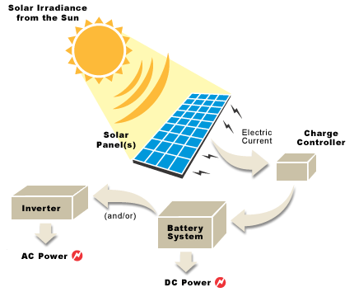

*PV System http://howtousesolarenergy.blogspot.com*

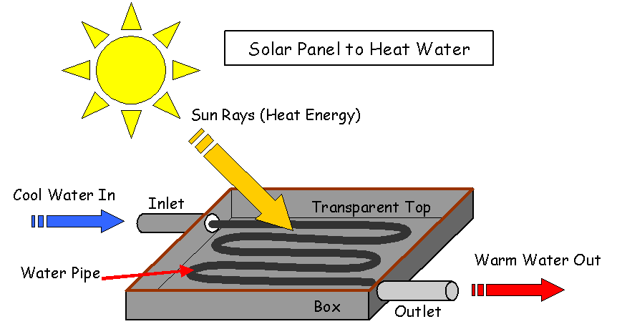

*Solar Hot Water Heater http://www.makeitsolar.com*