**HONORS, AWARDS, ACTIVITIES**

**Faculty**

* Invention: CERC affiliate faculty and Physics professor Dr. Xiaomei Jiang’s research has produced the smallest working organic solar cells that generate electricity on see-thru glass. The spray-on organic photovoltaic coating which remains transparent when applied onto glass is a significant breakthrough. This first-ever technology will help combat escalating energy costs and concerns over the environment. Her invention was unveiled in September and was successfully transferred to industry.
* Global Venture: FESC co-PI and Chemical Engineering professor Dr. John Wolan, graduate student, Syed Ali Gardezi and Jaideep Rajput of the USF Division of Patents and Licensing, earned an Honorable Mention for their biomass fuel reactor which converts common organic materials into fuel, in the Global Venture Challenge 2010. The competition is sponsored by the U.S. Dept. of Energy and leading technology and venture capital organizations.
* Mentioned: FESC Co-PI and Physics professor Dr. Matthias Batzill’s work on advancing graphene electronics was reported in a recent issue of *Nature Nanotechnology.* Graphene appears to be the material that will overcome the fundamental physical limitations of silicon.
* Excellence in Design Awards: FESC co-PI and Architecture professor Stanley Russell garnered an Honor’s Award for excellence in architectural design for the Zero Energy House Learning Center, during the 2010 Design Awards ceremony of the American Institute of Architects, Tampa Bay Chapter in August. This 1,000 sq. ft. house prototype will function as a learning center for students, faculty and the general public on the USF-Tampa campus.
  + Russell won a second Honor’s Award for his design of the Temple Terrace River Park pavilion. The 600 sq. ft. pavilion used natural material and harmonizes with the park’s surroundings. The pavilion will serve as a viewing point for a bat tower.

**Students**

* Best Paper: CERC post-doctoral fellow Dr. Sarada Kuravi and colleague Dr. Sesha Srinivasan of Tuskegee University won Best Paper for “Effect of Nb205 on the Hydrogen Storage Characteristics of Li-nMg-B-N-H Complex Hydrides” at the 2010 International Conference on Engineering and Meta-Engineering (ICEME) in Orlando during the Spring.
* Graduating: CERC graduate student Huijuan Chen earned her Ph.D. degree in Chemical Engineering for her research into “The Conversion of Low-grade Heat into Power using Supercritical Rankine Cycles.” Dr. Chen has already netted employment with GE in New York State.
* REU Winners Honored: CERC-sponsored Anthony D’Angelo was among other successful College of Engineering Research Experience for Undergraduates (COE REU) winners honored at a reception at the Library of Congress in October. D’Angelo’s work “Advanced Hydride Materials for Hydrogen Storage” won the 2009 REU award. The reception was co-sponsored by the Council on Undergraduate Research and the National Conferences on Undergraduate Research.
* COE Research Week Winners:
  + FESC-sponsored undergraduate Lucky Landrigan won First Place for his poster “Exploiting Metal-support Interaction to Optimize Dispersion and Reducibility of a Highly Active and Selective Fischer-Tropsch Synthesis Catalyst.” Landrigan was awarded a $500 travel grant in October. His advisor is John Wolan.
  + CERC graduate student Kofi Dalrymple won Honorable Mention for his poster “The Application of the Fermi Function and the Weibull Distribution for Modeling Survival and Resistance of *E. coli* to Photocatalytic Disinfection.” Dalrymple was awarded a $100 travel grant in October. His advisors are Lee Stefanakos and Yogi Goswami.

**Visitors**

* 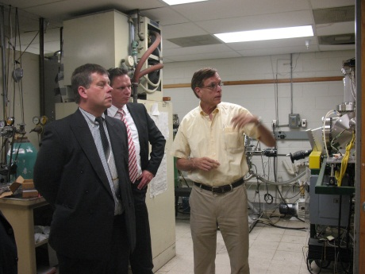Investors from Sybac Solar exploring clean energy as avenues for possible manufacturing operations in the Tampa area visited CERC during the Summer. The tour was arranged by the Tampa Hillsborough Economic Development Corporation. Sybac Solar is a leader in the design and installation of high performance solar PV systems. FESC co-PI and CERC affiliate professor Don Morel (R) explains his cutting edge solar PV research to Artur Madej and Markus Franz of Sybac Solar.
* 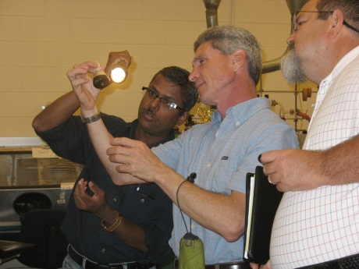Scientists from NuEnergy Technologies discussed advanced hydrogen storage systems using novel materials during a visit to CERC this Summer. NuEnergy Technologies is a developer and marketer of ground-breaking renewable energy products and consulting services. CERC affiliate scientist Dr. Sesha Srinivasan (L) illuminates a sample for Eric McCall and Hector Guervera.
* Clean Energy Symposia Series Seminar:
  + Dr. Sunity Sharma of Ameratek Corp. (Santa Clara, California) presented “Decorative Metallic Coatings to Printing Circuits” in October.
  + Dr. D.K. Aswal of Bhabha Atomic Research Center (Mumbai, India) presented “Hybrid Nanoelectronics” during the Summer.