**CERC -- HONORS, AWARDS, ACTIVITIES**

**Faculty**

* Invention: CERC affiliate faculty and Physics professor Dr. Xiaomei Jiang’s research has produced the smallest working organic solar cells that generate electricity on see-thru glass. The spray-on organic photovoltaic coating which remains transparent when applied onto glass is a significant breakthrough. This first-ever technology will help combat escalating energy costs and concerns over the environment. Her invention was unveiled in September and was successfully transferred to industry.

**Students**

* Best Paper: CERC post-doctoral fellow Dr. Sarada Kuravi and colleague Dr. Sesha Srinivasan of Tuskegee University won Best Paper for “Effect of Nb205 on the Hydrogen Storage Characteristics of Li-nMg-B-N-H Complex Hydrides” at the 2010 International Conference on Engineering and Meta-Engineering (ICEME) in Orlando during the Spring.
* Graduating: CERC graduate student Huijuan Chen earned her Ph.D. degree in Chemical Engineering for her research into “The Conversion of Low-grade Heat into Power using Supercritical Rankine Cycles.” Dr. Chen has already netted employment with GE in New York State.
* REU Winners Honored: CERC-sponsored Anthony D’Angelo was among other successful College of Engineering Research Experience for Undergraduates (COE REU) winners honored at a reception at the Library of Congress in October. D’Angelo’s work “Advanced Hydride Materials for Hydrogen Storage” won the 2009 REU award. The reception was co-sponsored by the Council on Undergraduate Research and the National Conferences on Undergraduate Research.
* COE Research Week Winners:
  + CERC graduate student Kofi Dalrymple won Honorable Mention for his poster “The Application of the Fermi Function and the Weibull Distribution for Modeling Survival and Resistance of *E. coli* to Photocatalytic Disinfection.” Dalrymple was awarded a $100 travel grant in October. His advisors are Lee Stefanakos and Yogi Goswami.

**Visitors**

* 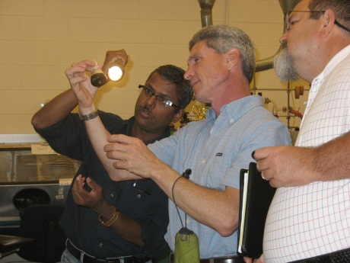Scientists from NuEnergy Technologies discussed advanced hydrogen storage systems using novel materials during a visit to CERC this Summer. NuEnergy Technologies is a developer and marketer of ground-breaking renewable energy products and consulting services. CERC affiliate scientist Dr. Sesha Srinivasan (L) illuminates a sample for Eric McCall and Hector Guervera.
* Clean Energy Symposia Series Seminar:
  + Dr. Sunity Sharma of Ameratek Corp. (Santa Clara, California) presented “Decorative Metallic Coatings to Printing Circuits” in October.
  + Dr. D.K. Aswal of Bhabha Atomic Research Center (Mumbai, India) presented “Hybrid Nanoelectronics” during the Summer.