**FESC -- HONORS, AWARDS, ACTIVITIES**

**Faculty**

* Global Venture: FESC co-PI and Chemical Engineering professor Dr. John Wolan, graduate student, Syed Ali Gardezi and Jaideep Rajput of the USF Division of Patents and Licensing, earned an Honorable Mention for their biomass fuel reactor which converts common organic materials into fuel, in the Global Venture Challenge 2010. The competition is sponsored by the U.S. Dept. of Energy and leading technology and venture capital organizations.
* Excellence in Design Awards: FESC co-PI and Architecture professor Stanley Russell garnered an Honor’s Award for excellence in architectural design for the Zero Energy House Learning Center, during the 2010 Design Awards ceremony of the American Institute of Architects, Tampa Bay Chapter in August. This 1,000 sq. ft. house prototype will function as a learning center for students, faculty and the general public on the USF-Tampa campus.
  + Russell won a second Honor’s Award for his design of the Temple Terrace River Park pavilion. The 600 sq. ft. pavilion used natural material and harmonizes with the park’s surroundings. The pavilion will serve as a viewing point for a bat tower.
* Presented: Addressing the potential for electrical power generation for Florida by harnessing the natural energy sources of wind and solar, along with ocean currents and waves, FESC researcher and Marine Science professor Bob Weisberg of USF-St. Petersburg gave an invited presentation on "Alternative Power Generation for Florida by Mechanical and Solar Means" at the Florida Atlantic University Alternative Energy Conference in November.
* Presented: The sustainable algal biofuels group (Civil and Environmental Engineering professors Sarina Ergas, Yu Zhang and James Milhelcic, and Chemical Engineering professor John Wolan) gave a presentation on the integration of algal biofuel production into recirculating aquaculture systems at the Water Environment Federation Nutrient Recovery and Management Conference in Miami Florida 2010.
* Mentioned: FESC Co-PI and Physics professor Dr. Matthias Batzill’s work on advancing graphene electronics was reported in a recent issue of *Nature Nanotechnology.* Graphene appears to be the material that will overcome the fundamental physical limitations of silicon.

**Students**

* COE Research Week Winners:
  + FESC-sponsored undergraduate Lucky Landrigan won First Place for his poster “Exploiting Metal-support Interaction to Optimize Dispersion and Reducibility of a Highly Active and Selective Fischer-Tropsch Synthesis Catalyst.” Landrigan was awarded a $500 travel grant in October. His advisor is John Wolan.

**Visitors**

* 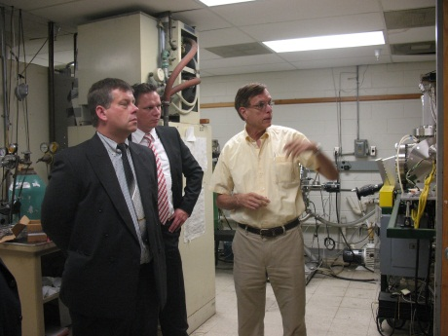Investors from Sybac Solar exploring clean energy as avenues for possible manufacturing operations in the Tampa area visited CERC during the Summer. The tour was arranged by the Tampa Hillsborough Economic Development Corporation. Sybac Solar is a leader in the design and installation of high performance solar PV systems. FESC co-PI and CERC affiliate professor of Electrical Engineering Don Morel (R) explains his cutting edge solar PV research to Artur Madej and Markus Franz of Sybac Solar.