The Florida Energy Systems Consortium is effectively implementing its research, education, industrial collaboration, and technology commercialization agenda. FESC faculty members statewide are successfully collaborating in research and proposal development toward new sustainable energy technologies for Florida’s future. Here are some updates on two of our USF FESC research projects.

* **Developing Florida’s biomass resources: thermo-chemical conversion**

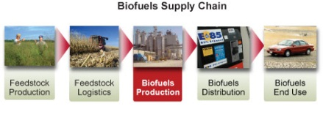

The State of Florida produces more biomass than any other state in the U.S. (~7% of total). Given the state’s dependence on imported oil for transportation fuels and the value of transportation to our tourism industry, developing methods to convert this resource to fuels is important. The Consortium is pursuing microbial and gasification routes to produce this carbon-neutral fuel. In addition, algae production systems promise a direct route to fuel, along with its use for bioremediation of agricultural waste water 9 and production of products from the residual biomass. There are 13 FESC funded projects under this thrust in the areas of algae, energy crops, biochemical conversion (cellulosic ethanol, plastics from biomass, etc), and thermochemical conversion (biofuels, waste to energy, new catalyst development), and biogasification. There is great progress in the energy crop research.

**Title:** Production of Liquid Fuels Biomass via Thermo-Chemical Conversion Processes **PI:** Babu Joseph **Co-PI’s:** Yogi Goswami, Venkat Bhethanabotla, John Wolan, Vinay Gupta

The chemical composition of biomass is a critical determinant of the yield of energy from biomass. The thermo-chemical conversion of lingocellulosic biomass (non-food grade biomass such as agricultural waste, bagasse from sugar mills, citrus peels, switch grass, municipal green waste, etc.) to clean burning liquid fuels requires efficient catalyst. Researchers at USF performed catalyst design by using density functional theory (DFT) simulations in the molecular scale. The testing moved up to pilot scale. The liquid product produced has been analyzed and report good yield in the diesel and jet fuel range.

The objective of this project is to develop technology for the economical thermo-chemical conversion of lingocellulosic biomass (non-food grade biomass such as agricultural waste, bagasse from sugar mills, citrus peels, switch grass, municipal green waste, etc.) to clean burning liquid fuels. Five of the major advantages of this process over a biochemical route to production of ethanol are: (i) it does not utilize food-grade feed stocks and therefore complements and does not compete with the agricultural food production in the state, (ii) the fuel produced is similar to those derived from petroleum unlike ethanol derived fuels which have at least a 25% lower energy content, (iii) the conversion is accomplished in using fast chemical reactions unlike the slow biological reactions for fermenting alcohol, (iv) the process does not require large amounts of water and associated energy costs of separating the water from the fuel as in bioethanol processes, (v) it can utilize a wide variety of biomass sources unlike the biochemical route which cannot work with high lignin containing biomass.

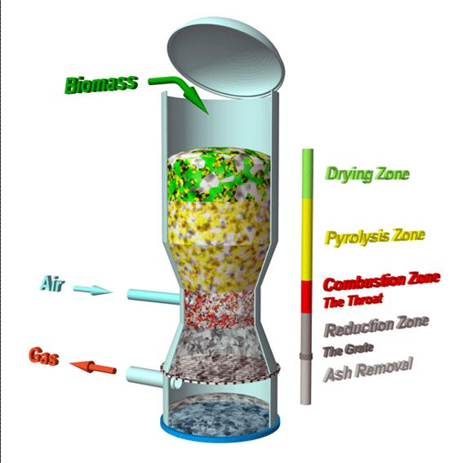







* **Harnessing Florida's Solar Resources**

The Sunshine State has more solar insolation than any state east of the Mississippi River and the conversion of sunlight to electric power or fuel promises to be an important contribution to the State’s renewable energy portfolio. Photovoltaics (PV) directly converts light to electricity and can be deployed in a distributed manner. Both thin film and organic PV technologies as well as systems integration are being pursued by Consortium faculty.

[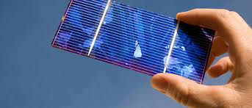](http://www.google.com/imgres?imgurl=http://www.solarnovus.com/images/stories/Features/Front_Page/Machine_vision_2010-06_4500163_654x280.jpg&imgrefurl=http://www.solarnovus.com/index.php%3Foption%3Dcom_content%26view%3Darticle%26id%3D833:machine-vision-aids-photovoltaic-manufacturing%26catid%3D38:application-tech-features%26Itemid%3D246&usg=__Q1y00nuEldePnqcXlhyKHHkYgN8=&h=280&w=654&sz=79&hl=en&start=54&zoom=1&tbnid=jAvmDOJDJI2tyM:&tbnh=60&tbnw=139&ei=1hc_TbaQKMT38Abgv-HRCg&prev=/images%3Fq%3Dsolar%2Bpv%2Bproduction%26hl%3Den%26sa%3DG%26rls%3Dcom.microsoft:en-us%26rlz%3D1I7RNSM_en%26biw%3D773%26bih%3D375%26tbs%3Disch:1&itbs=1&iact=hc&vpx=215&vpy=86&dur=94&hovh=147&hovw=343&tx=200&ty=72&oei=Lhc_TZrrDMSclger6siPAw&esq=14&page=8&ndsp=9&ved=1t:429,r:1,s:54)

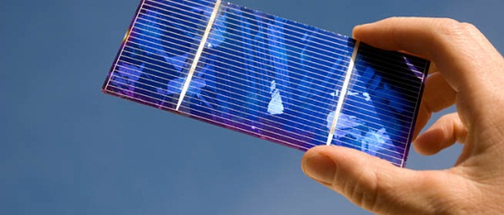

**Title:** Solar Photovoltaic Manufacturing Facility to Enable a Significant Manufacturing Enterprise within the State and Provide Clean Renewable Energy (**PI:** Don Morel, USF; **Co-PI’s:** Chris Ferekides, USF, Lee Stefanakos, USF, Tim Anderson, UF, Neelkanth Dhere, FSEC)

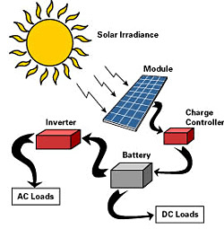

The primary goal of this project is to enable the establishment and success of local solar photovoltaic manufacturing companies to produce clean energy products for use within the state and beyond and to generate jobs and the skilled workforce needed for them. Thin film technologies have shown record efficiencies of 20%, and present tremendous opportunities for new Florida start-up companies. USF, UCF, and UF are collaborating to develop a pilot line facility for thin film solar technologies, which will serve as a test bed for making ongoing improvements in productivity and performance of solar modules, develop advanced manufacturing protocols, and help train a skilled workforce to ensure the success of new companies.

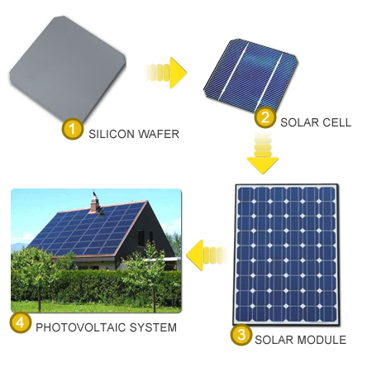

Goswami

Concentrated solar thermal energy is also being explored for conversion to electricity, production fuels and feed stocks as well as water desalination. The Sunshine State has more solar insolation than any state east of the Mississippi River and the conversion of sunlight to electric power or fuel promises to be an important contribution to the State’s renewable energy portfolio. Photovoltaics (PV) directly converts light to electricity and can be deployed in a distributed manner. Both thin film and organic PV technologies as well as systems integration are being pursued by Consortium faculty. Concentrated solar thermal energy is also being explored for conversion to electricity, production fuels and feed stocks as well as water desalination.

**Title:** Design, Construction and Operation of CSP Solar Thermal Power Plants in Florida **PI :** Yogi Goswami **Co-PI’s:** Lee Stefanakos, David Hahn, Robert Reddy

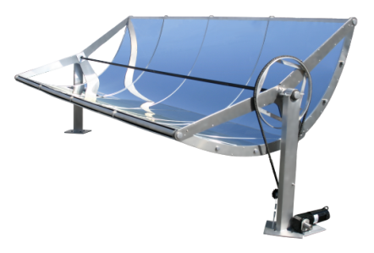

Sopogy micro concentrated solar power trough – Goswami’s team is using Sopogy products

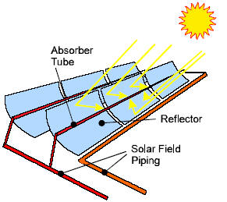

Florida utilities are mandated to achieve 20% renewable energy contribution to their generation mix by 2020. While technologically feasible with solar energy, the capital costs are high – presently, capital costs range from $6,000-$7,000/kW for PV and $3,500-$4,000/kW for concentrating solar thermal power. This project targets the development of solar thermal power technology for bulk power and distributed generation, which will diversify energy resources in Florida and reduce greenhouse emissions by utilizing renewable sources. Also, there will be economic impacts with the establishment of new power industry in Florida, which will help the electrical utilities of the state to meet the renewable portfolio standards. The project has three main tasks; the first one is to develop design methodologies and standards for the proven solar thermal power technologies in combination with bio or fossil fuels based on Florida conditions and resources. Secondly, the project aims to set up demonstration and test facilities for these technologies for optimization for Florida conditions, and the final task is to develop and commercialize innovative technologies based on new thermodynamic cycles.

**Zero energy house**

Stanley Russell

Developing innovative energy-efficient building technologies that minimize the use of natural resources and utilize renewable and sustainable materials will result in sustainable and economically viable communities.

USF is leading the Zero Energy Home Learning Center (ZEHLC) project in collaboration with FSU and the Florida Solar Energy Center, construction and interior design experts from UF, and industry partner Palm Harbor Homes. The project is in Design Development phase. The researchers developed a hybrid envelope that can be opened during the cooler/dryer months of the year and closed when temperature and humidity levels are too high to achieve an acceptable comfort range in the house. Informed by FSEC studies that have shown that the majority of heat gain comes through the roof of Florida homes, the ZEHLC employs a shading device that covers the entire roof and the east and west walls to reduce heat gain by eliminating direct solar radiation through the building envelope.

**Title:** Energy Efficient Technologies and The Zero Energy Home Learning Center **PI:** Stanley Russell **Co-PI’s:** Yogi Goswami **Graduate Assistant**: Mario Rodriguez

**Description:** The project is to create and evaluate an affordable residential scale Zero Energy building that will function as an exhibition of energy efficiency and Zero Energy Home [ZEH] technology on or near the University of South Florida campus. The Zero Energy Home Learning Center [ZEHLC] will feature the most cost-effective combination of renewable solar energy with high levels of building energy efficiency. The building will incorporate a carefully chosen package of the latest energy-.efficiency technologies and renewable energy systems to achieve the most successful and reliable results. The building will utilize Photovoltaic solar electricity and solar domestic hot water heating systems using the grid as an energy storage system, producing more energy than needed during the day and relying on the grid at night. Plug-in hybrid automobile technology offers a promising means of providing distributed energy storage for such homes but has not been sufficiently tested. Using a systems approach to couple zero energy home technology with PHEVs we will explore opportunities to develop marketable products that meet Florida’s energy and environmental goals

