**TECHNOLOGY TRANSLATES TO JOBS**

Florida Governor Rick Scott met with business, political and education leaders during a tour of new technologies and the economic potential of university research to create jobs, at USF in December. Looking at the best and brightest inventions USF has generated in the last few years, Scott heard an overview of dozens of state-of-the art research projects, business development and entrepreneurial services, during his statewide jobs tour.

The governor toured a large collection of emerging technologies in the atrium of USF Connect (an incubator for spin-off companies created by USF researchers and other high-tech start-ups), surveying presentations on drug development, marine science technologies, equipment for people with disabilities, and emerging solar energy technology.

The Clean Energy Research Center and Florida Energy Systems Consortium displayed ground breaking research into rectenna-based solar energy harvesting, photocatalytic detoxification and disinfection, and concentrated solar power generation.

Scott, who won office on a pro-business and job-creation platform, also met with area education, business and political leaders in a town hall-style format to discuss the state’s economic recovery. Scott maintains that his 7-step business plan to invigorate the State’s economy includes teaming up universities more with the private sector. Scott is determined to keep his campaign pledge of creating 700 jobs in 7 years.

The governor’s advocacy for entrepreneurship echoes a central theme of USF President Judy Genshaft’s decade-long administration: research universities are key economic engines and harbor the expertise, innovation and creativity to create new industries.

“USF works as an economic engine for work sites producing new jobs and companies, President Judy Genshaft said. Many of the new technologies have already created jobs. “This is phenomenal,” she said.

Scott said he would focus on lowering regulatory barriers that may hinder new businesses coming to Florida, reduce the size of state government and aggressively position the state nationally and internationally as a good place to do business.

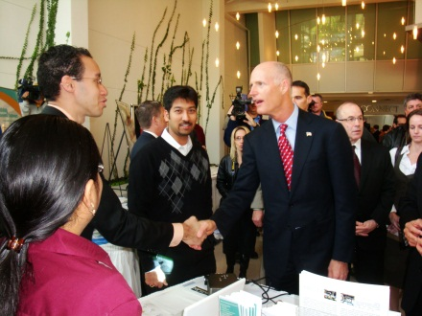

Governor Rick Scott greets CERC graduate student Michael Celestin.

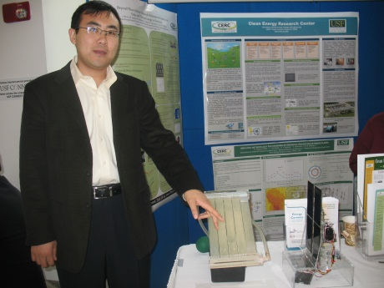

CERC graduate student Stephan Lee explains the solar photocatalytic disinfection and detoxification process.

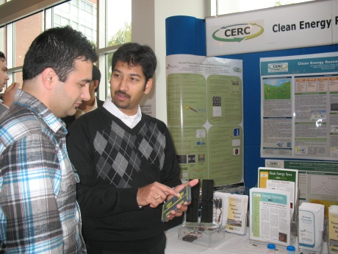

CERC assistant director Dr. Subbu Krishnan explains rectenna solar energy harvesting to graduate student Saeb Bessarati.

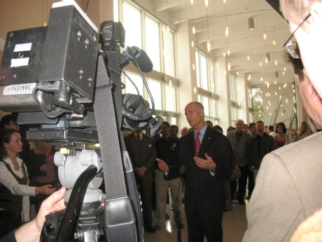

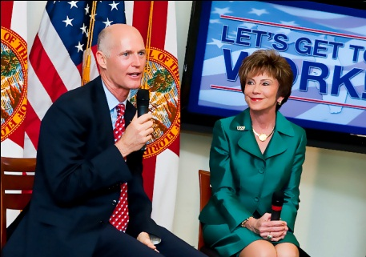Governor Rick Scott was interviewed by regional media while touring the USF Research Park in December.

Governor Rick Scott and USF President Judy Genshaft discussed teaming up universities with the private sector.

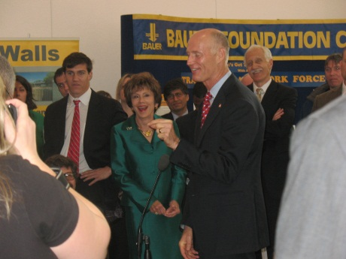

Governor Rick Scott emphasizes a point during the press conference at USF. CERC co-director Yogi Goswami looks on (back row, center).