**SUPER HERO TEACHER**

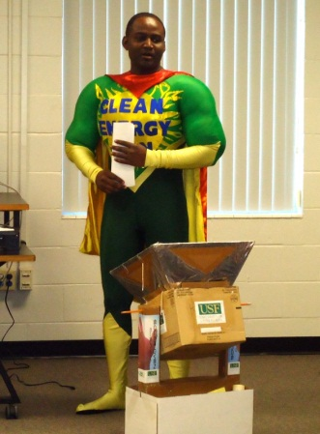“Clean Energy Man” breezed in to the 2010 Great American Teach-In, visiting students at Cox Elementary School in Pasco County during November. In its 17th year, the Teach-In continues to surprise, delight and educate students with its wide array of topics. As part of the event, CERC’s Kofi Dalrymple as Clean Energy Man made an exciting presentation including a homemade solar oven. Other presentations included fire and police officers, a pilot, a news reporter, and a therapy dog.

*If needed; boxed sidebar:*

***HEROES INTRIGUE THE PUBLIC***

*Clean energy sure isn’t boring –- that’s the message CERC sends each time our Clean Energy Man (CEM) super hero appears! The whimsy factor helps attract attention and generates excited interest in an otherwise complicated science.*

*“We were looking for a way to get adults and kids to come over and observe all the cool stuff that the CERC engages in, and we felt that ‘CEM’ would embody both the ‘coolness’ and intellectual genius of our work,” reflected Clean Energy Man Kofi Dalrymple. “He leaves a strong mental image for most people who come into contact with him, especially the children. Everyone keeps talking about clean energy as the way of the future, but when ‘CEM’ shows up, people just seem to get it!”*