**SOLAR PARK AT USF**

A pilot solar thermal power plant and a zero energy home which will demonstrate and teach students new research in renewable energies renewable energy technologies will soon find a home at a newly developing Solar Park to be located off of Alumni Drive. This is an exciting arena for the USF, which is fast becoming a solar energy mecca for the Tampa Bay.

The extremely innovative pilot solar thermal power plant will generate 100 KW of electricity from solar energy. This electricity will be used for USF’s needs and will be fed into the utility’s electricity grid. The power plant utilizes the ground breaking science of concentrated solar power and high temperature thermal energy storage capsules. *[See related story, “Concentrated Solar Power Shines on USF.”]*

A zero energy building, to be called the “Zero Energy Learning Center,” will also be built on the Solar Park site. This “Flex House” will be built by “Team Florida”, made up of architecture students from the University of South Florida, Florida State University, University of Central Florida, and the University of Florida, is entered into the National Solar Decathlon competition in Washington, DC scheduled for September.

After the competition the house will be brought back to the USF campus.

“Zero Energy” does not mean that no energy is used -– it means that it produces the same amount of energy that it uses. The energy produced is from renewable energies; when it produces more energy than is needed that energy will be fed directly into the utility grid; and those times it produces less energy than it requires, energy will be drawn from battery storage devices or from the grid. For more information: <http://www.flexhouse.org/>.

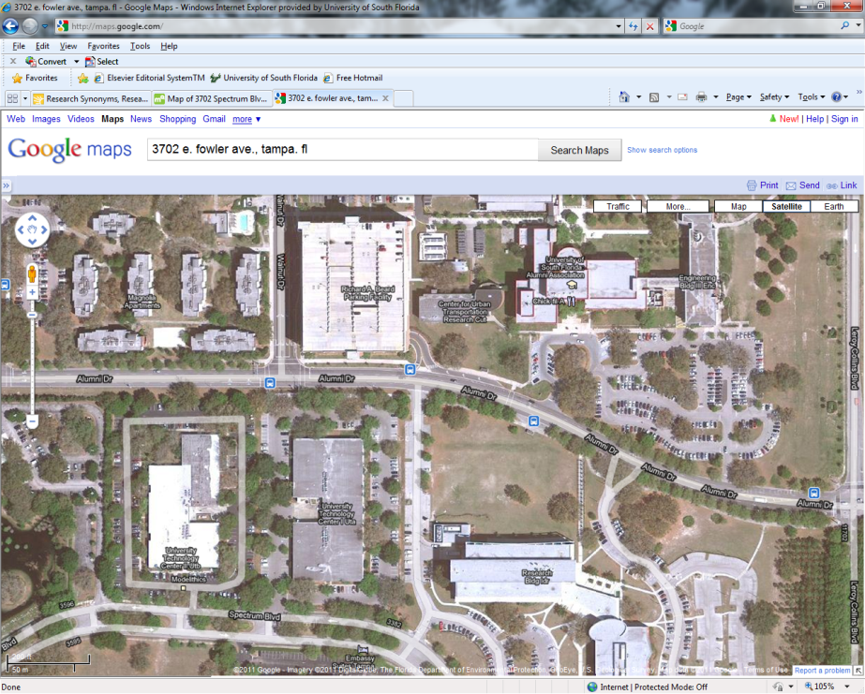

The Solar Park site is located between Alumni Drive and Spectrum Blvd.

