**Solar Car Port Renovated**

The original CERC PV array car port was the nation’s first 20,000 watt solar/electric charging station for electric vehicles. During the Spring, half of the system was renovated with new thin film PV modules to provide an additional 10kW of electricity to be tied to the USF utility grid. An award from the USF Student Green Energy Fees and TECO matching funds made the project possible. CERC professors Zhixin Miao, Lee Stefanakos and Yogi Goswami oversaw the renovation.

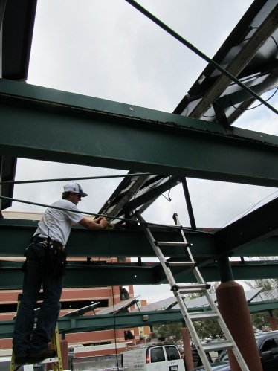

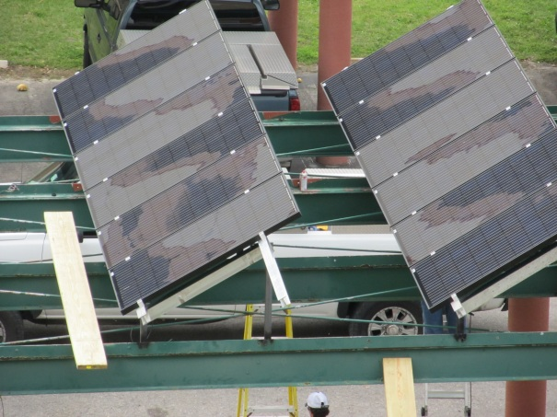

*(L) A workman installing new PV modules; (R) new thin film PV modules atop the USF CERC’s electric car port charging station, located adjacent to the Engineering buildings.*

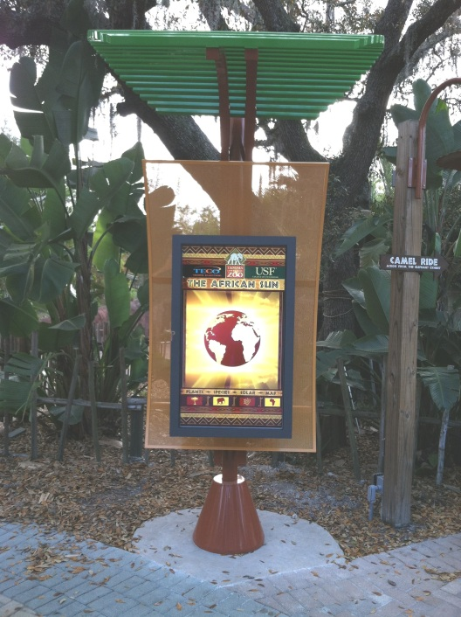

**Solar Tree at the Zoo**

A solar tree has taken root at the Lowery Park Zoo. CERC director Prof. Lee Stefanakos worked with TECO Energy and Lowry Park Zoo to implement a “solar tree” kiosk. The kiosk acts as a portal to several information categories at the aoo. The homepage has links to several exhibits across the zoo. One page links to the power collection stations at the Elephant Exhibit, the Solar Tree and several TECO power solar arrays located throughout the city. The solar tree is a work in process according to designers.

The tree is designed on the concept of the sun’s energy being absorbed by the leaves of trees in the process of photosynthesis. Each one of the branches with a single solar PV panel on its end collects 5 watts of power. The direct current voltage is collected in tandem with 26 other PV panels through each of the electrical conduit “branches” for a total output of 52 watts of power.

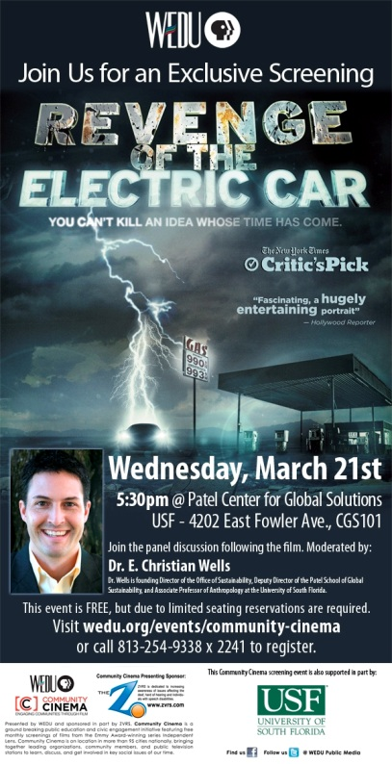**The Revenge of the Electric Car**

USF’s Patel School of Global Sustainability and public television channel, WEDU, hosted a special screening of “The Revenge of the Electric Car” as part of the “Community Cinema” event in March, at the Patel Center. The film’s director, Chris Paine, took his crew behind the closed doors of Nissan, GM, and the Silicon Valley start-up company Tesla Motors to chronicle the story of the global resurgence of electric cars. Without using foreign oil, this new generation of car seems to be America’s future. Still, daunting obstacles persist, like battery life and driving range limits, production costs and consumer friendly pricing. Additionally the consumer infrastructure of charging stations has not been built, making long trips problematic.

CERC’s Prof. Lee Stefanakos provided thought provoking questions to the panelists following the screening. He expressed his view that the present production of electric cars by three major companies is a very important development and will contribute significantly to the widespread use of electric cars. However, he also pointed out that considerable additional research and development is still needed in battery technology and battery capacity in order to increase the vehicle range to a point comparable to that of internal combustion cars. Important developments must also take place in Electric Vehicle (EV) charging and charging station infrastructure. The high cost of EVs must also be reduced, something that may happen as the production of EVs increases.

**Engineering Expo**

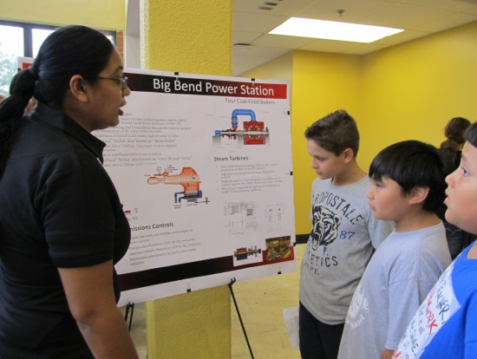CERC’s recent Master’s graduate Ms. Drupatie Latchman explained the Big Bend Power Station to students attending USF’s 39th Engineering EXPO. This year’s theme is “Imagine Your Future.” The Expo is a free event open to everyone, young or old, who has an interest in science, technology, engineering and math (STEM). Thousands of K-12 students and their teachers attend EXPO to learn how engineering and science play a big part of their everyday lives. Ms. Latchman graduated in 2010; her thesis is entitled “Carbon Dioxide Capture from Fossil Fuel Power Plants Using Dolomite.” She now works for TECO Energy, in Hillsborough County.

**Faculty and Graduate Student Activities**

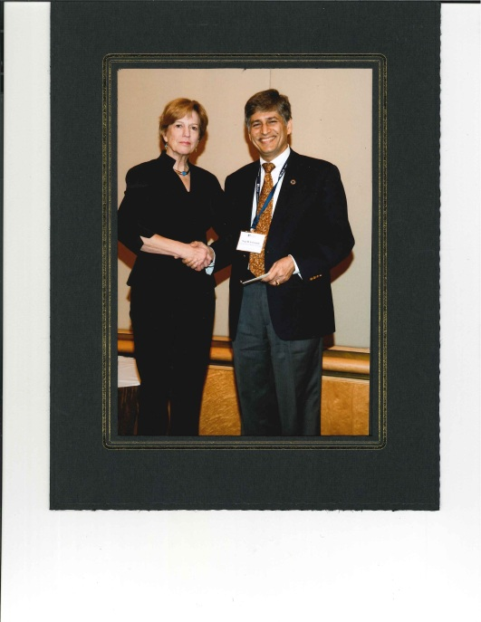

* Yogi Goswami was honored by being named a Fellow of the American Association for the Advancement of Science (AAAS), in Washington, in March. AAAS Fellows are recognized for their contributions and efforts on behalf of the advancement of science or that its applications are scientifically or socially distinguished.

*Nina V. Fedoroff Chair of the AAAS Board*

*presents the Fellow distinction to Prof. Yogi Goswami*

* Babu Joseph won the USF 2010-2011 Outstanding Undergraduate Teaching Award. CoE Dean John Wiencek presented the award during the 2012 College of Engineering Awards Banquet in May.
* Yogi Goswami was awarded the USF 2011 College of Engineering Outstanding Research Achievement Award. CoE Dean John Wiencek presented the award during the 2012 College of Engineering Awards Banquet in May.
* 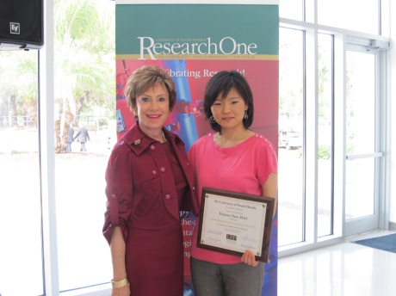In April the USF awarded CERC’s recent graduate Dr. Huijuan Chen with the 2011 Outstanding Thesis and Dissertation (OTD) Award, at the USF Scholars of Excellence “Scholarship and Leadership in Action” ceremony. The OTD Award recognizes graduate alumni whose research exemplifies the highest quality. The award recognizes those USF graduates who have demonstrated exceptional performance and whose thesis or dissertation has resulted in significant impact to the discipline at the national level. Dr. Chen’s dissertation is entitled “The Conversion of Low Grade Heat into Power Using Supercritical Rankine Cycles. Chen graduated from the Dept. of Chemical and Biomedical Engineering in November 2010. Dr. Chen works for GE in New York State.

*USF President Dr. Judy Genshaft presents the OTD award to Dr. Huijuan Chen.*

**Clean Energy Symposia Series**

* February: Dr. Rahul Singhal, of the University of Puerto Rico, gave a seminar on “Biofuels: Some Limitations.” He addressed some limitations for the production and commercialization of biofuels as a renewable and sustainable energy sources.
* March: Dr. Elham B. Makram, of the Electric Power Research Association at Clemson University, Clemson SC, gave a seminar on “Coastal Wind Energy Impact on South Carolina Transmission System.” She discussed the power transmission system of South Carolina and the effect of wind energy penetration on the grid.
* May: Dr. Mohammad Abutayeh, of NextEra Energy Resources, Juno Beach, FL, gave a seminar on “Solar Power Generation.” He discussed how such renewable energy can be generated directly via photovoltaic cells or indirectly via concentrating solar power systems; noting that CSP systems can be directly integrated into existing power plants.

**Visiting Scholars**

* Myriam Solis Lopez: Ms. Solis Lopez is spending six months with the CERC investigating photocatalysts in water purification. Her home university is the Universidad Nacional Autónoma de México (UNAM), in Mexico City, Mexico
* Yuichi Tomazawa: Dr. Tomazawa is spending six months with CERC developing micro-sized valves in the microfluidic channel for electrochemical detection of cortisol from the human blood. He obtained his Ph.D. in materials science from the Japan Advanced Institute of Science and Technology (JAIST), in Kanazawa City, Japan.
* Thi Minh Huynh Thu Nguyen: Mrs. Nguyen spent a month with CERC continuing her Ph.D. studies which center on renewable energy technologies. Her home university is the Keio University in Yokohama, Japan. She returned to Viet Nam after her time with CERC.

**Tours**

* CERC Ph.D. student Ms. Jamie Trahan gave a tour of CERC labs to a group of young women from the Bayshore High School Women in Science and Engineering group in May. Ms.Trahan discussed the varied research and scientific experimentation at the CERC. Bayshore High School is in Bradenton, Florida.
* CERC affiliate professor Dr. Wilifredo Moreo coordinated meetings and presentations for academic collaboration with faculty from the Universite Nacional, Bototá, Colombia, in April. CERC Prof. Yogi Goswami gave a presentation and tour of the CERC laboratories. CERC graduate student Antonio Ramos Archibold provided translating services.

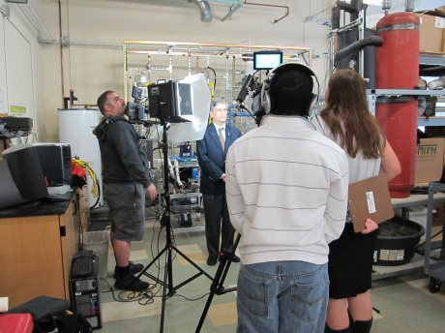

**International Recruitment**

In February, the USF’s Media Innovation Team interviewed CERC’s Prof. Yogi Goswami in the laboratory as part of an public outreach film to encourage and recruit students from around the world. Dr. Goswami spoke about CERC’s research into clean and renewable energies.