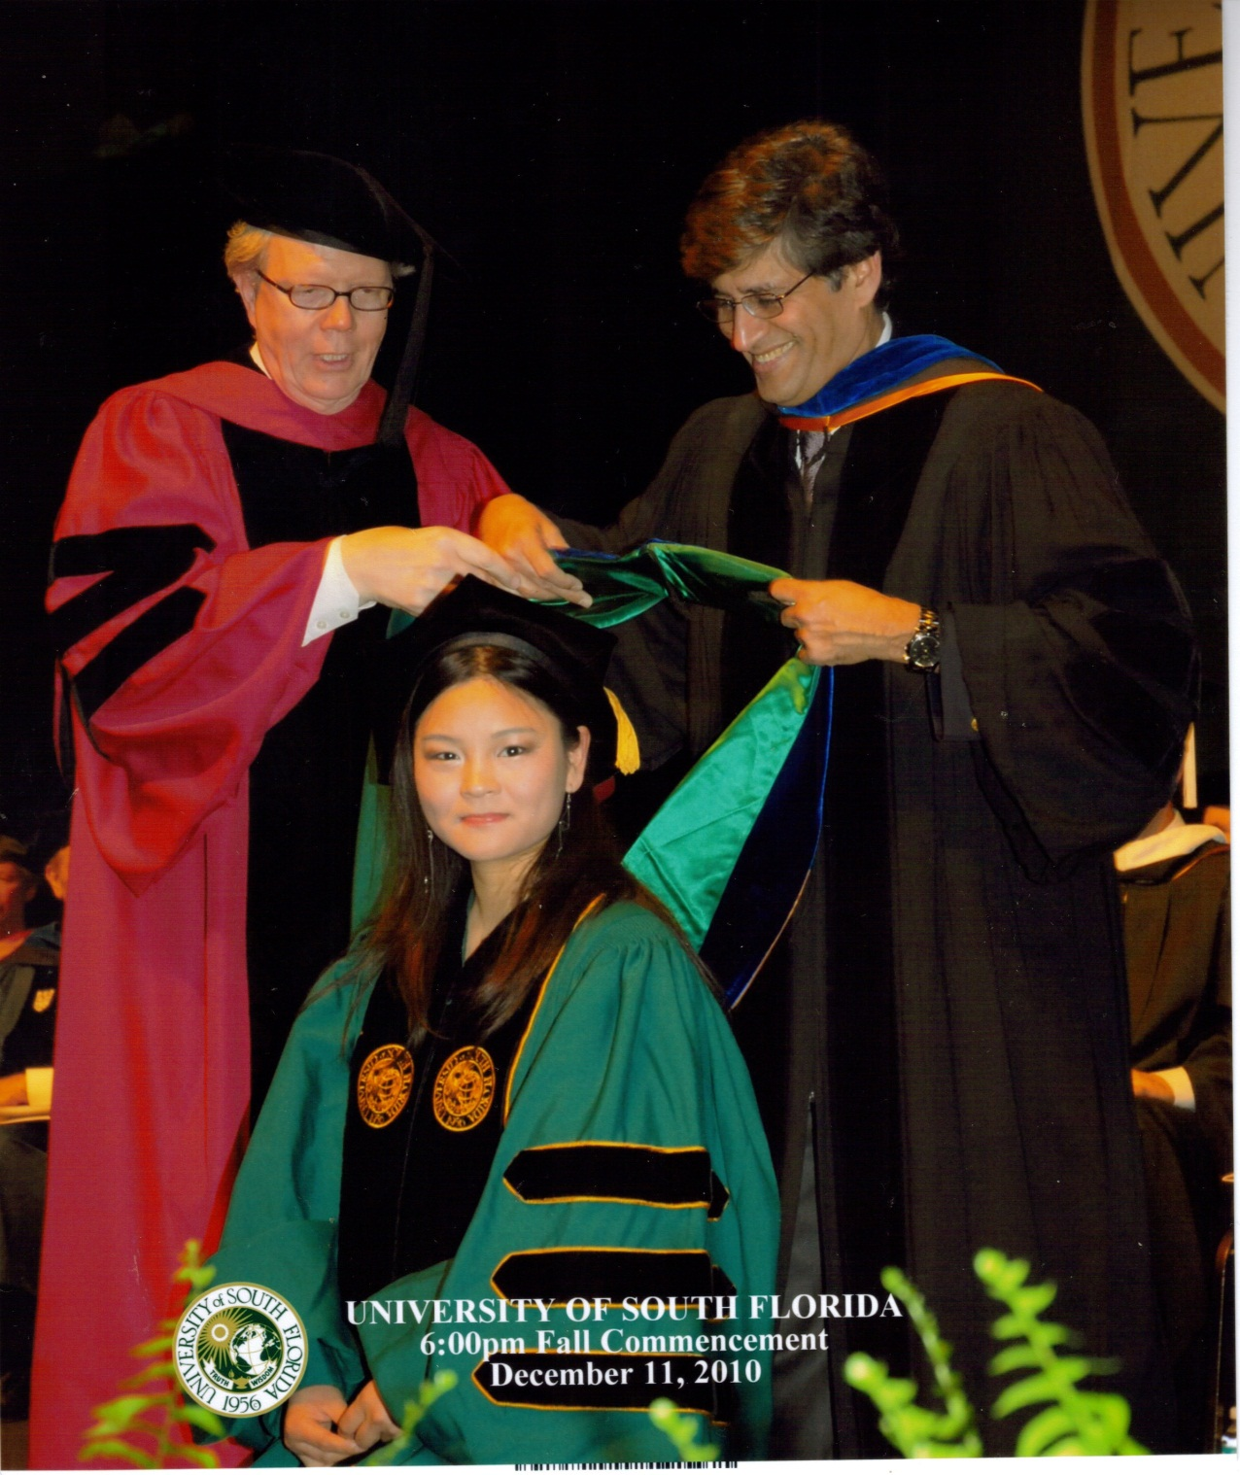

***CERC Graduate Student Huijuan Chen received her Ph.D. with Honors at the December 11 Fall Commencement.***

***June is pictured with her committee chairman Prof. Yogi Goswami and Dr. XXX XXXXX, as they hood her denoting her honors achievements.***