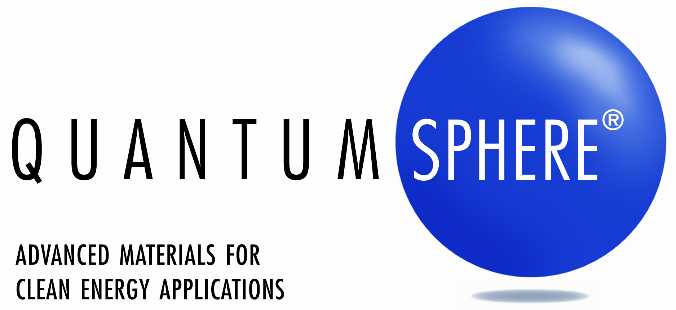

**NEWS RELEASE**

CONTACT:

Kevin Maloney

QuantumSphere, Inc.

714-545-6266

**QuantumSphere and University of South Florida Achieve Critical Milestone in Solid State Hydrogen Storage**

*QuantumSphere’s advanced nanoscale materials**integrated with complex hydrides exceed U.S. Department of Energy’s 2010 targets, which could enable safe and economical hydrogen storage for portable power applications*

**SANTA ANA, Calif.** – **December 15, 2009** – QuantumSphere, Inc. and the University of South Florida today announced that they have exceeded the 2010 Department of Energy (DOE) goals for solid state hydrogen storage. Achieving these goals fosters the commercialization of safe, lightweight fuel storage for portable, stationary power, and transportation applications.

In a two year materials discovery program funded by QuantumSphere, Inc., Professor Elias Stefanakos, director of the Clean Energy Research Center (CERC) at the University of South Florida, and Research Associate Dr. Sesha Srinivasan (currently an assistant professor at Tuskegee University), have developed complex metal hydrides doped with QuantumSphere’s nano-Nickel particles produced by its patented manufacturing process. These materials have a 6-8 wt% reversible hydrogen capacity below 150oC. This compares to the 6 wt% system efficiency target set by the DOE, as this is believed to be the threshold at which hydrogen can be economically stored as a solid. These results have been confirmed independently by the Southwest Research Institute (SWRI) and the National Institute of Standards and Technology (NIST).

Hydrogen is the most abundant element in the universe and has the highest energy content – three times more than gasoline on a per-pound basis. Unfortunately, it is a gas at room temperature and typically stored in pressurized tanks at 5,000 to 10,000 psi. This presents handling, packaging, safety, and storage challenges and increases the size and weight of power systems. Alternatively, hydrogen stored in the solid state requires lower pressure (100 to 1,000 psi), is safer to handle, and has a simplified, lightweight tank design. However, prior to the QuantumSphere and University of South Florida breakthrough, there had been limited success in discovering solid-state materials capable of effectively storing hydrogen reversibly at practical operating temperatures. This has limited the deployment of hydrogen as a fuel carrier for portable electricity generation.

“The high-performance materials designed by QuantumSphere and CERC enables high energy density, solid-state, reversible hydrogen storage systems and will foster the commercialization of hydrogen fuel cells,” said Prof. Stefanaoks. “Fulfilling the need for lightweight storage is especially important in early market applications such as uninterruptable power supplies and unmanned systems.”

“We are impressed with the high caliber of research performed at the University of South Florida,” said Dr. Kimberly McGrath, director of fuel cell research at QuantumSphere. “We are focused on demonstrating the value of these new materials at the system level for power applications in the 1-10kW range.” Dr. McGrath added, “Furthermore, the fundamental nanomaterials knowledge we have gained has directly translated into the development of higher capacity materials for nickel-metal hydride batteries.”

A summary of the research and full technical whitepaper can be found at: [www.qsinano.com](http://www.qsinano.com).

**About the Clean Energy Research Center**

The mission of the University of South Florida’s Clean Energy Research Center (CERC) is to develop, evaluate, and promote commercialization of new environmentally clean energy sources and systems such as hydrogen, fuel cells, solar energy conversion, biomass utilization, etc., that meet the needs of the electric power and the transportation sector through multi-disciplinary research, technical and infrastructure development, and information transfer. The Center supports regional economic development of manufacturing and high technology business, in conjunction with the National goals of improving our global competitiveness and technology leadership. The development of hydrogen storage materials has received significant financial support over the past three years, from the US Department of Energy through a cross-cutting DOE grant awarded to Drs. Elias Stefanakos and Yogi Goswami. For additional information, please visit <http://cerc.eng.usf.edu/>.

**About QuantumSphere**

QuantumSphere, Inc. (QSI) leverages its award winning advanced catalyst materials and process chemistry expertise to develop, manufacture, and license solutions for a broad range of portable power and clean-tech applications. The company's proprietary products, available in commercial volume, are used by industry leading companies to lower costs and enable breakthrough performance in established multi-billion dollar and high-growth markets such as batteries and fuel cells for portable power, emissions reduction for transportation and stationary power applications, and chemical synthesis of ammonia for food production.

Founded in 2002, QSI's mission is to reduce dependence on non-renewable energy sources and provide near-term, revolutionary, portable power and clean-technology products. QSI achieves this through continuous innovation and refinement of its proprietary catalyst materials, unique process chemistries, high-performance electrode systems, and other advanced technology platforms. Please turn up your speakers and [click here](http://www.impactmovie.com/quantum_sphere/) to learn more about QuantumSphere or visit our website at [www.qsinano.com](http://www.qsinano.com).