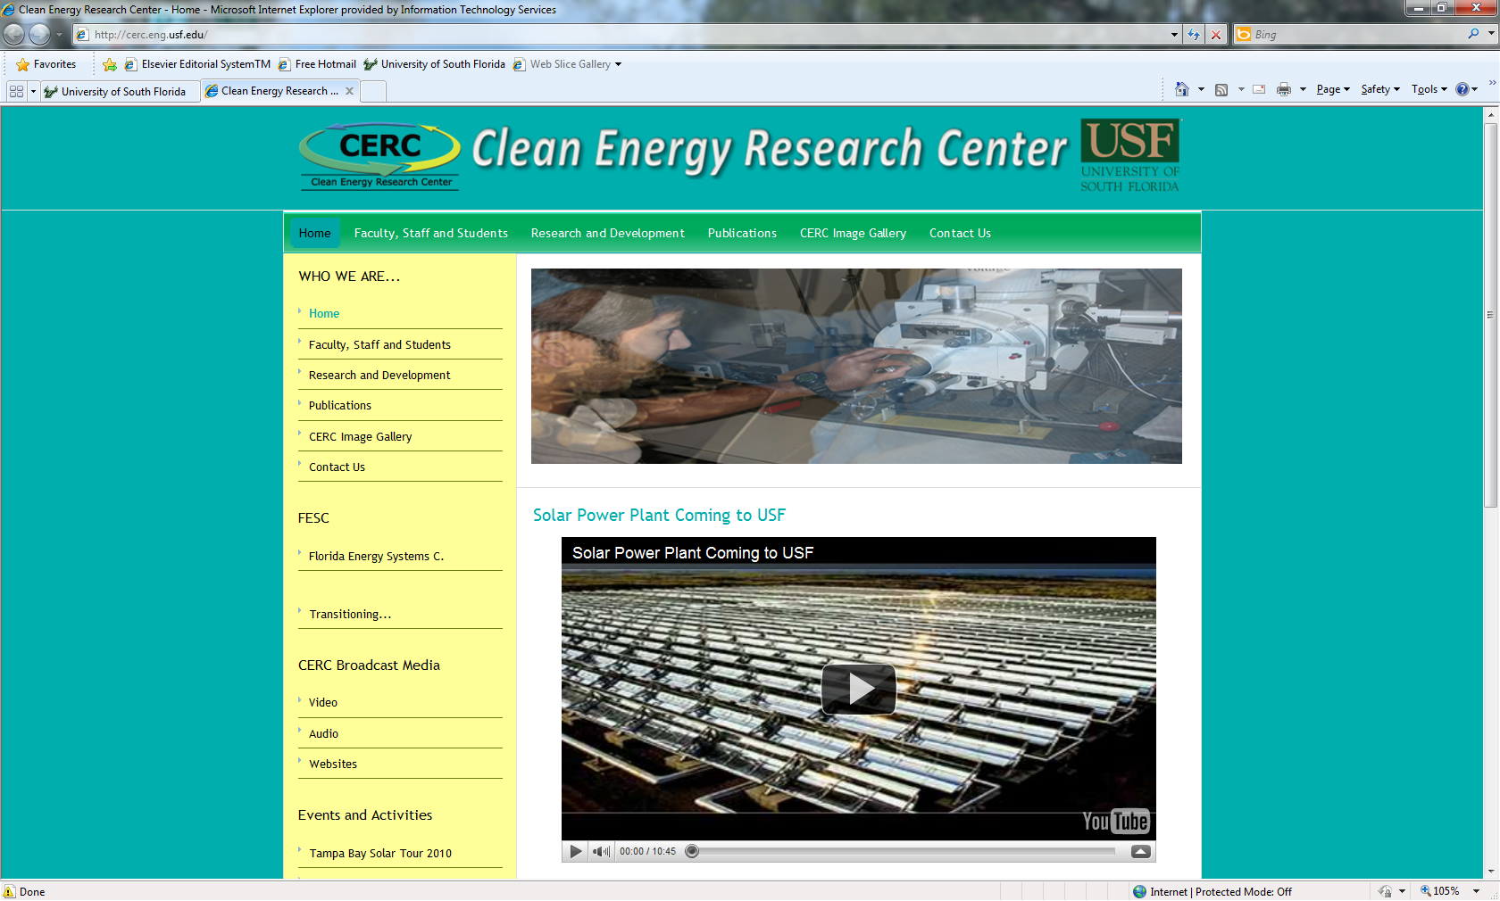

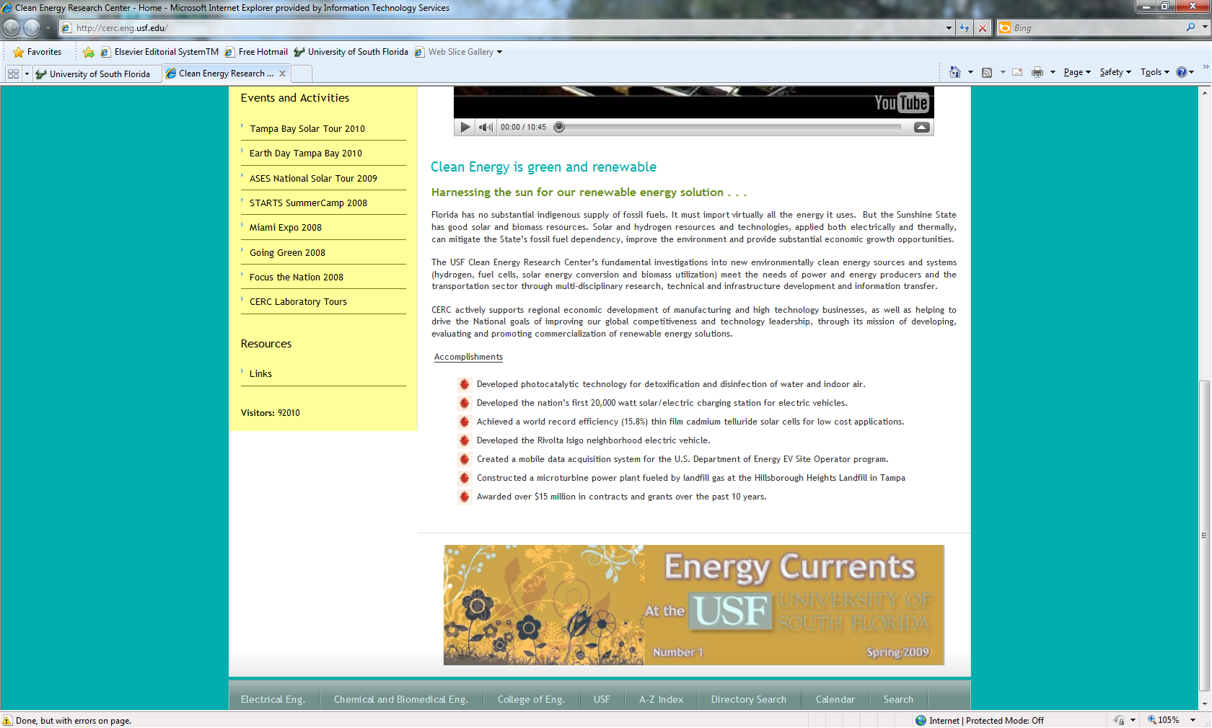

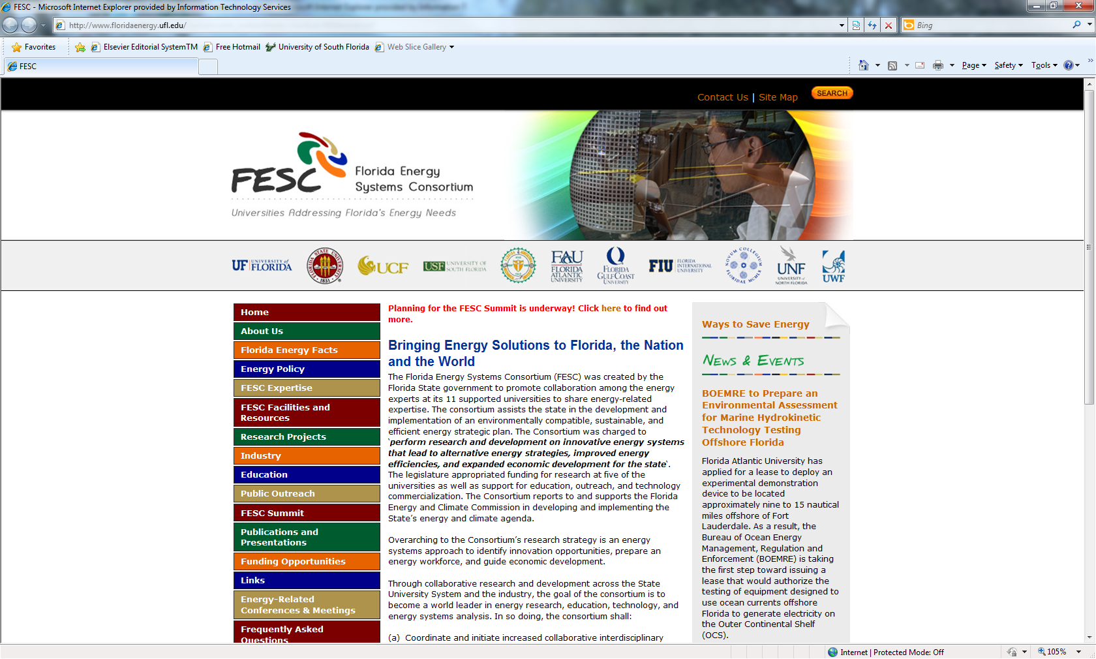

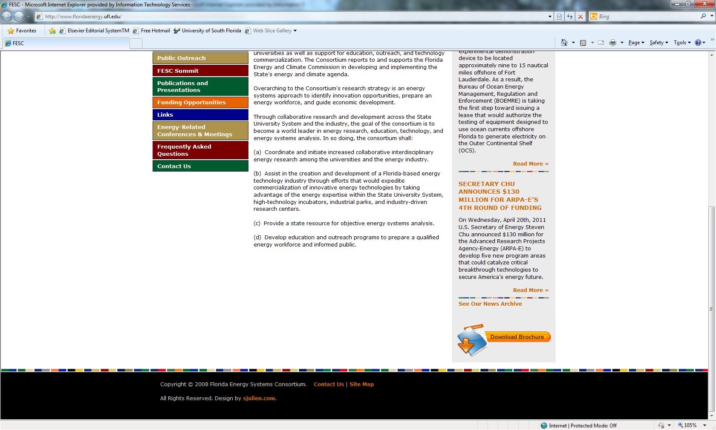WHO WE ARE...

|  |
| --- |
| [Home](http://cerc.eng.usf.edu/index.php?option=com_frontpage&Itemid=1) |
| [Faculty, Staff and Students](http://cerc.eng.usf.edu/index.php?option=com_content&task=view&id=80&Itemid=390) |
| [Research and Development](http://cerc.eng.usf.edu/index.php?option=com_content&task=view&id=44&Itemid=96) |
| [Publications](http://cerc.eng.usf.edu/index.php?option=com_content&task=view&id=45&Itemid=97) |
| [CERC Image Gallery](http://cerc.eng.usf.edu/index.php?option=com_wrapper&Itemid=381) |
| [Contact Us](http://cerc.eng.usf.edu/index.php?option=com_contact&Itemid=3) |

FESC

|  |
| --- |
| [Florida Energy Systems C.](http://cerc.eng.usf.edu/index.php?option=com_content&task=view&id=58&Itemid=107) |
| [Transitioning...](http://cerc.eng.usf.edu/index.php?option=com_content&task=view&id=149&Itemid=419) |

CERC Broadcast Media

|  |
| --- |
| [Video](http://cerc.eng.usf.edu/index.php?option=com_content&task=blogcategory&id=20&Itemid=192) |
| [Audio](http://cerc.eng.usf.edu/index.php?option=com_content&task=blogcategory&id=21&Itemid=193) |
| [Websites](http://cerc.eng.usf.edu/index.php?option=com_content&task=blogcategory&id=41&Itemid=420) |

Events and Activities

|  |
| --- |
| [Tampa Bay Solar Tour 2010](http://cerc.eng.usf.edu/index.php?option=com_content&task=view&id=154&Itemid=424) |
| [Earth Day Tampa Bay 2010](http://cerc.eng.usf.edu/index.php?option=com_content&task=view&id=152&Itemid=421) |
| [ASES National Solar Tour 2009](http://cerc.eng.usf.edu/index.php?option=com_content&task=view&id=59&Itemid=374) |
| [STARTS SummerCamp 2008](http://cerc.eng.usf.edu/index.php?option=com_wrapper&Itemid=376) |
| [Miami Expo 2008](http://cerc.eng.usf.edu/index.php?option=com_wrapper&Itemid=380) |
| [Going Green 2008](http://cerc.eng.usf.edu/index.php?option=com_wrapper&Itemid=375) |
| [Focus the Nation 2008](http://cerc.eng.usf.edu/index.php?option=com_content&task=view&id=60&Itemid=377) |
| [CERC Laboratory Tours](http://cerc.eng.usf.edu/index.php?option=com_wrapper&Itemid=378) |

Resources

|  |
| --- |
| [Links](http://cerc.eng.usf.edu/index.php?option=com_content&task=view&id=136&Itemid=394) |

**Visitors:** 92010

